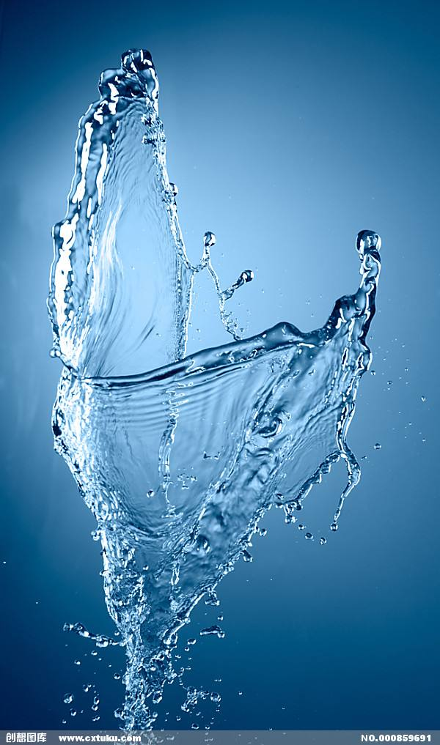
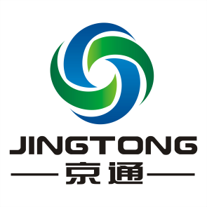

JINGTONG PIPELINE
PLASTIC PIPES AND FITTINGS CATALOGUE

Tianjin Jingtong Pipeline Technology Co.Ltd.
天津京通管道科技股份有限公司

Company Profile
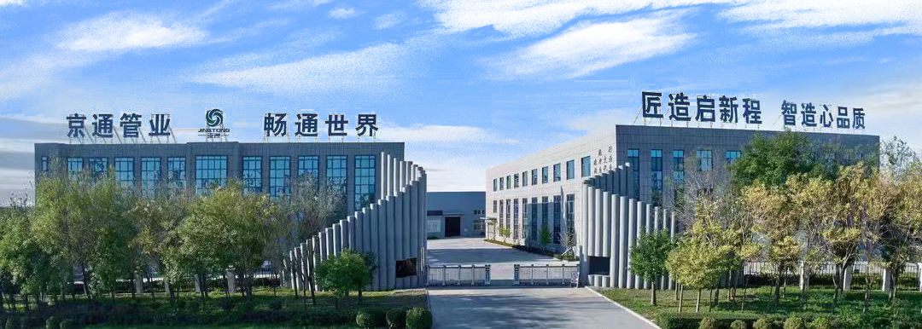

Tianjin Jingtong Pipeline Technology Co.,Ltd. locates in Tianjin China, close to Beijing airport and Tianjin Xingang port, which was founded in 1998,and nowadays has become a main manufacturer of a premium quality range of plastic pipe systems in north of China.The main products include HDPE pipe, SRTP pipe,SRPE pipe,HDPE corrugated pipe and UPVC pipe ,CPVC/MPP cable pipe and fittings etc,production capability reaches 100000 metric tons per year.

JINGTONG pipes and fittings systems are known for their sustainability,longevity,non-toxicity,and corrosion resistance,widely used in a broad range of applications such as plumbing, potable water supply,sewerage and drainage,building and construction,mining,industry, rural and irrigation,electrical ,telecommunications and gas.The pipes that we bring forth for our clients are made available in a range of sizes and pressure applications to cater to the demands of the customers,which have been exported to more than 40 countries and regions.

JINGTONG works with our materials suppliers to ensure our products are made with the input of continuous research and development to ensure high quality, durability, performance and safety. JINGTONG has CNAS nationally accredited laboratories and European Union CE certification,UK water safety WRAS cert and BV ,SGS certificates. It has successively passed through ISO9001:2015 international quality management system, ISO14001:2015 international environmental management system and ISO45001:2018 occupational health and safety management system certification.

150+ staffs employees and R&D

40+ countries of exportation and regions

25+ years experience of manufacturing

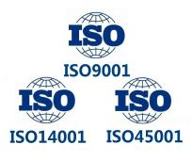

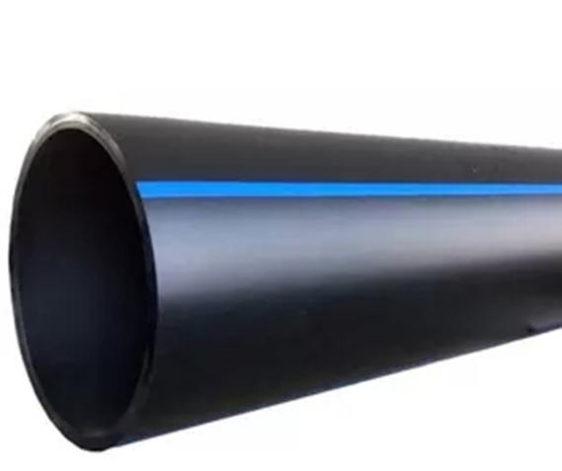
- Polyethylene (PE100) Pipe for water supply
Nominal Size DN=OD | Pipes Series
Nominal Size DN=OD | SDR41 | SDR33 | SDR26 | SDR21 | SDR17 | SDR13.6 | SDR11 | SDR9
Nominal Size DN=OD | S20 | S16 | S12.5 | S10 | S8 | S6.3 | S5 | S4
Nominal Size DN=OD | Nominal Pressure (PN),MPa
Nominal Size DN=OD | 0.4 | 0.5 | 0.6 | 0.8 | 1.0 | 1.25 | 1.6 | 2.0
mm | nominal wall thickness (en),mm
16 | - | - | - | - | - | - | - | 2.3
20 | - | - | - | - | - | - | 2.3 | 2.3
25 | - | - | - | - | - | - | 2.3 | 3
32 | - | - | - | - | - | - | 3.0 | 3.6
40 | - | - | - | - | - | - | 3.7 | 4.5
50 | - | - | - | - | - | - | 4.6 | 5.6
63 | - | - | - | - | - | 4.7 | 5.8 | 7.1
75 | - | - | - | - | 4.5 | 5.6 | 6.8 | 8.4
90 | - | - | - | 4.3 | 5.1 | 6.7 | 8.2 | 10.1
110 | - | - | 4.2 | 5.3 | 6.6 | 8.1 | 10.0 | 12.3
125 | - | - | 4.8 | 6.0 | 7.4 | 9.2 | 11.4 | 14.0
140 | - | - | 5.4 | 6.7 | 8.3 | 10.3 | 12.7 | 15.7
160 | - | - | 6.2 | 7.7 | 9.5 | 11.8 | 14.6 | 17.9
180 | - | - | 6.9 | 8.6 | 10.7 | 13.3 | 16.4 | 20.1
200 | - | - | 7.7 | 9.6 | 11.9 | 14.7 | 18.2 | 22.4
225 | - | - | 8.6 | 10.8 | 13.4 | 16.6 | 20.5 | 25.2
250 | - | - | 9.6 | 11.9 | 14.8 | 18.4 | 22.7 | 27.9
280 | - | - | 10.7 | 13.4 | 16.6 | 20.6 | 25.4 | 31.3
315 | 7.7 | 9.7 | 12.1 | 15.0 | 18.7 | 23.2 | 28.6 | 35.2
355 | 8.7 | 10.9 | 13.6 | 16.9 | 21.1 | 26.1 | 32.2 | 39.7
400 | 9.8 | 12.3 | 15.3 | 19.1 | 23.7 | 29.4 | 36.3 | 44.7
450 | 11 | 13.8 | 17.2 | 21.5 | 26.7 | 33.1 | 40.9 | 50.3
500 | 12.3 | 15.3 | 19.1 | 23.9 | 29.7 | 36.8 | 45.4 | 55.8
560 | 13.7 | 17.2 | 21.4 | 26.7 | 33.2 | 41.2 | 50.8 | 62.5
630 | 15.4 | 19.3 | 24.1 | 30 | 37.4 | 46.3 | 57.2 | 70.3
710 | 17.4 | 21.8 | 27.2 | 33.9 | 42.1 | 52.2 | 64.5 | 79.3
800 | 19.6 | 24.5 | 30.6 | 38.1 | 47.4 | 58.8 | 72.6 | 89.3
900 | 22.0 | 27.6 | 34.4 | 42.9 | 53.3 | 66.2 | 81.7 | -
1000 | 24.5 | 30.6 | 38.2 | 41.7 | 59.3 | 72.5 | 90.2 | -
1200 | 29.4 | 36.7 | 45.9 | 57.2 | 67.9 | 88.2 | - | -
1400 | 34.3 | 42.9 | 53.5 | 66.7 | 82.4 | 102.9 | - | -
1600 | 39.2 | 49.0 | 61.2 | 76.2 | 94.1 | 117.6 | - | -

Material | Polyethylene PE100
Size (DN) | Dn16-dn1600
Pressure(PN) | PN4-PN20
Standard | GB/T13663,ISO4427,EN12201,AS/NZS4130,  GOST18599,ASTM F714(ISO sizing),
Length | Dn16-dn110 300m-50m/coil  Dn16-dn1600  6m or 12m/pc,  as per customers
Features
- Good sanitation, non-toxic
- Long service life,≥50 years
- Corrosion resistance
- Low friction coefficient
- Easy installation,low cost

Application
Widely used in municipal water supply, fire protection, industry, agriculture, mines, oil fields, dredging, and other water delivery projects.
Telecom & power cable protection

- Steel Wire Reinforced HDPE Composite Pipe (SRTP)

Nominal outside |  | Nominal Pressure (MPa)
Diameter (mm) |  | 1.0 | 1.25 | 1.6 | 2.0 | 2.5 | 3.5
Size/dn | tolerance | Nominal wall thickness (mm)
50 | +1.2/0 | - | - | 4.5 | 5.0 | 5.5 | 5.5
63 | +1.2/0 | - | - | 4.5 | 5.0 | 5.5 | 5.5
75 | +1.2/0 | - | - | 5.0 | 5.0 | 5.5 | 6.0
90 | +1.4/0 | - | - | 5.5 | 5.5 | 5.5 | 6.0
110 | +1.5/0 | 5.5 | 5.5 | 7.0 | 7.0 | 7.5 | 8.5
125 | +15/0 | 6.0 | 6.0 | 7.5 | 8.0 | 8.5 | 9.5
140 | +1.7/0 | 6.0 | 6.0 | 8.0 | 8.5 | 9.0 | 10.5
160 | +2.0/0 | 6.0 | 6.0 | 9.0 | 9.5 | 10.0 | 12.5
200 | +2.3/0 | 6.0 | 6.0 | 9.5 | 10.5 | 11.0 | -
225 | +2.5/0 | 8.0 | 8.0 | 10.0 | 10.5 | 11.0 | -
250 | +2.5/0 | 10.5 | 10.5 | 12.0 | 12.0 | 12.5 | -
315 | +2.7/0 | 11.5 | 11.5 | 13.0 | 13.0 | - | -
355 | +2.8/0 | 12.0 | 12.0 | 14.0 | - | - | -
400 | +3.0/0 | 12.5 | 12.5 | 15.0 | - | - | -
450 | +3.2/0 | 13.5 | 13.5 | 16.0 | - | - | -
500 | +3.2/0 | 15.5 | 15.5 | 18.0 | - | - | -
560 | +3.2/0 | 20.0 | - | - | - | - | -
630 | +3.2/0 | 23.0 | - | - | - | - | -
710 | +3.8/0 | 26.0 | - | - | - | - | -
800 | +3.8/0 | 30.0 | - | - | - | - | -
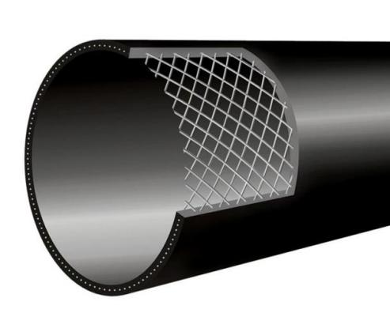

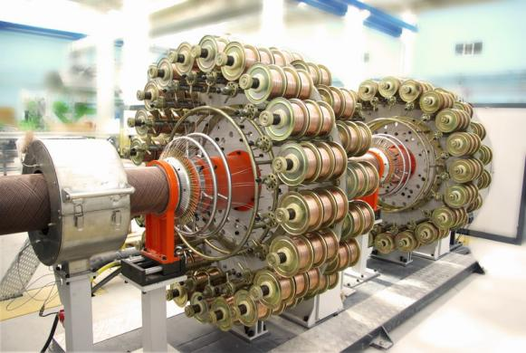
Material | Polyethylene PE100
Size (DN) | Dn50-dn800
Pressure(PN) | PN10-PN35
Standard | CJ/T189,GB/T32439
Length | 6m or 12m/pc,  as per customers

Features
HDPE SRTP pipe is a new type of composite structure wall pipe made of high-strength steel wire and polyethylene plastic as raw materials, with wrapped high-strength steel wire as the core layer and HDPE as the inner and outer layers, forming a whole pipe wall. It retains both the excellent pressure bearing performance of steel pipes and the good hygiene performance of plastic pipes, as well as the characteristics of easy installation, reliable technology, and long service life. Widely applicable to municipal and building water supply, fire protection pipelines, and gas transportation, it can also be used for the transportation of industrial media such as chemical, petroleum, and pharmaceutical industries.

- Steel Skeleton Reinforced HDPE Composite Pipe (SRPE)

INSIDE DIAMETER SERIES
Nominal Inside | Nominal Pressure (MPa)
Diameter(mm) | 1.0 | 1.6 | 2.0 | 2.5 | 4.0
DN/ID | Nominal wall thickness (mm)
50 | - | - | - | 9.0 | 10.6
65 | - | - | - | 9.0 | 10.6
80 | - | - | - | 9.0 | 11.7
100 | - | 9.0 | 9.0 | 11.7 | 11.7
125 | - | 10.0 | 10.0 | 11.8 | 12.3
150 | 12.0 | 12.0 | 12.0 | 12.0 | 15.5
200 | 12.0 | 12.0 | 12.5 | 12.5 | -
250 | 12.0 | 12.5 | 12.5 | 13.0 | -
300 | 12.5 | 12.5 | 12.5 | - | -
350 | 15.0 | 15.0 | 15.5 | - | -
400 | 15.0 | 15.0 | 15.5 | - | -
450 | 15.5 | 16.0 | 16.5 | - | -
500 | 15.5 | 16.0 | 16.5 | - | -
600 | 19.0 | 20.0 | - | - | -
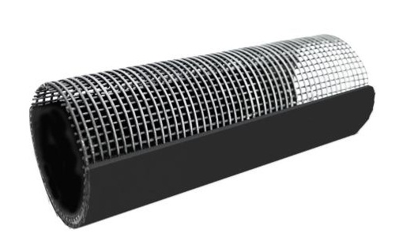

Material | Polyethylene PE100
Size (DN) | Dn50-dn600(ID series)  Dn75-dn630(OD series)
Pressure(PN) | PN10-PN40
Standard | CJ/T123,HG/T3690
Length | 6m or 12m/pc,  as per customers
OUTSIDE DIAMETER SERIES
Nominal Outside | Nominal Pressure (MPa)
Diameter(mm) | 1.0 | 1.6 | 2.0 | 2.5 | 4.0
DN/OD | Nominal wall thickness (mm)
75 | - | - | - | 9.0 | 9.0
90 | - | - | - | 9.0 | 9.0
110 | - | - | - | 9.0 | 9.0
125 | - | 9.0 | - | 9.0 | 9.0
140 | - | 10.0 | - | 10.0 | 10.0
160 | - | 12.0 | - | 12.0 | 12.5
200 | - | 12.0 | - | 12.0 | 12.5
225 | 12.0 | 12.0 | - | 12.0 | 12.5
250 | 12.5 | 12.5 | - | 13.0 | -
315 | 12.5 | 12.5 | - | 13.0 | -
355 | 14.0 | 14.0 | - | - | -
400 | 15.0 | 15.0 | - | - | -
450 | 15.0 | 15.0 | - | - | -
500 | 15.5 | 15.5 | - | - | -
560 | 15.5 | 16.0 | - | - | -
630 | 19.0 | 20.0 | - | - | -

Features
SRPE pipe has better internal and external compressive strength than SRTP pipes. It is welded with steel mesh and extruded with Polyethylene synchronously. The inner and outer layers of pipe walls are connected as a whole through metal mesh holes in the middle of the pipe wall. The structure is similar to reinforced concrete, and the two materials are Integrated into one entity. It can withstand high pressure like metal pipes and withstand various chemical substances like plastic pipes. It is an ideal substitute for traditional medium and low pressure pipelines. The product is widely used in industries such as petrochemicals, metallurgy and mining, electricity, airports and ports, municipal gas, and water supply and drainage.

- HDPE Pipe for the Supply of Gaseous fuels
Nominal Outside | Minimum wall thickness (mm)
Diameter(mm) | SDR11 | SDR17
20 |  | 3.0
25 |  | 3.0
32 | 3.0 | 3.0
40 | 3.0 | 3.7
50 | 3.0 | 4.6
63 | 3.8 | 5.8
75 | 4.5 | 6.8
90 | 5.4 | 8.2
110 | 6.6 | 10.0
125 | 7.4 | 11.4
140 | 8.3 | 12.7
160 | 9.5 | 14.6
180 | 10.7 | 16.4
200 | 11.9 | 18.2
225 | 13.4 | 20.5
250 | 14.8 | 22.7
280 | 16.6 | 25.4
315 | 18.7 | 28.6
355 | 21.1 | 32.3
400 | 23.7 | 36.4
450 | 26.7 | 40.9
500 | 29.7 | 45.5
560 | 33.2 | 50.9
630 | 37.4 | 57.3

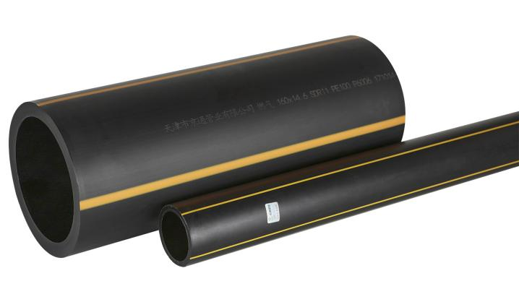
Material | Polyethylene PE100
Size (DN) | Dn20-dn630
Pressure(PN) | SDR11, SDR17
Standard | GB/T15558,ISO4437
Length | 6m or 12m/pc,  as per customers

Features
The color of the gas pipe is yellow or black, and there must be a prominent yellow color bar on the black pipe. PE gas pipes have performance characteristics such as reliable connection, good low-temperature impact resistance, good stress cracking resistance, good chemical corrosion resistance, aging resistance, long service life, good wear resistance, and good flexibility.

- HDPE Pipe Fittings for Water Supply
5.1Polyethylene Socket Fusion Fittings (SDR11 PN16) SIZE dn20-dn110
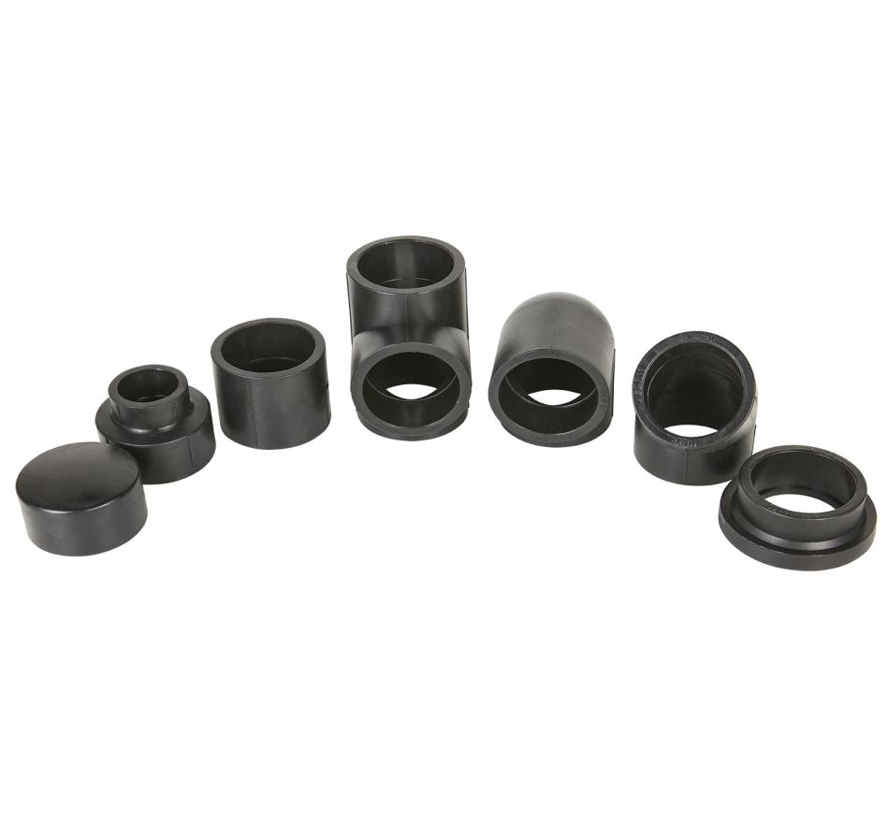
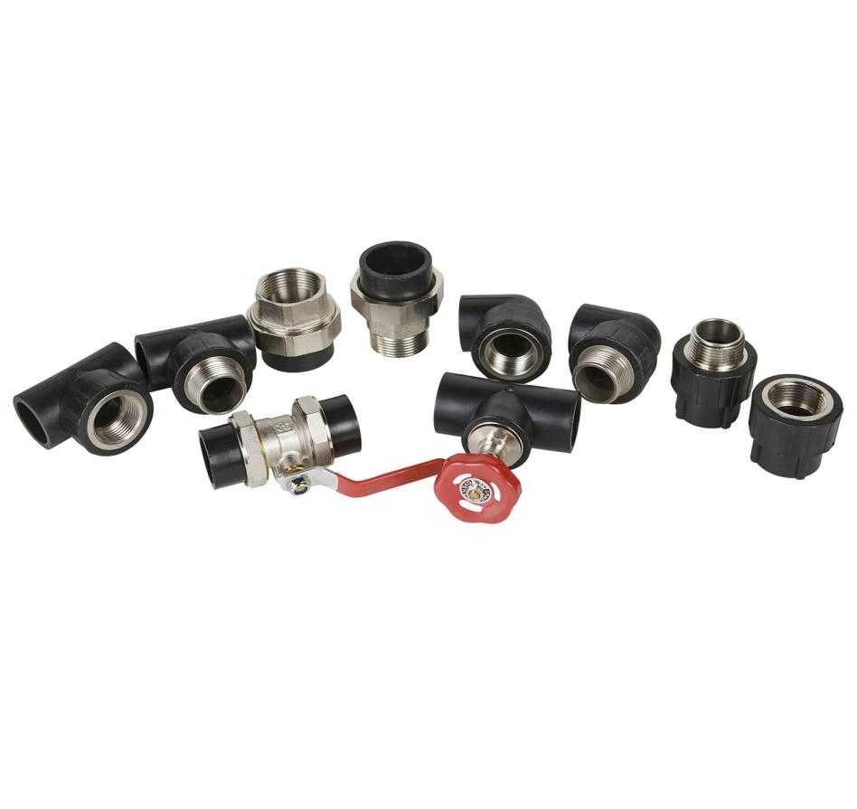

5.2Polyethylene Butt Fusion Fittings (SDR17,SDR13.6,SDR11) SIZE dn63-dn1600
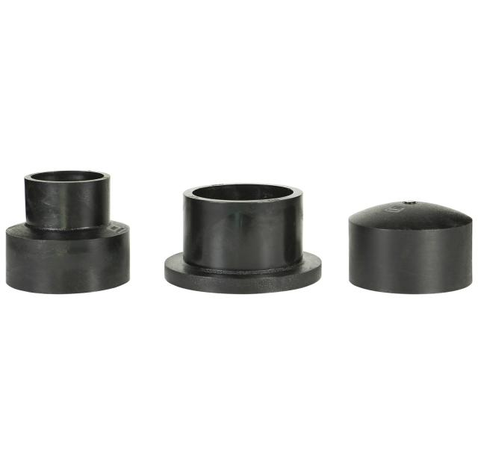
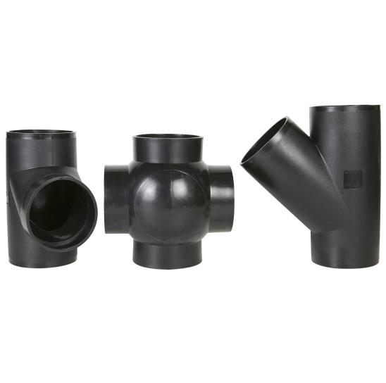
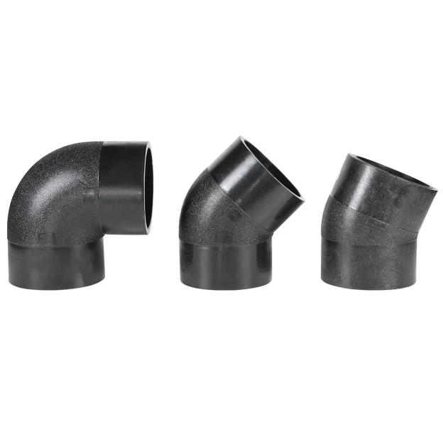
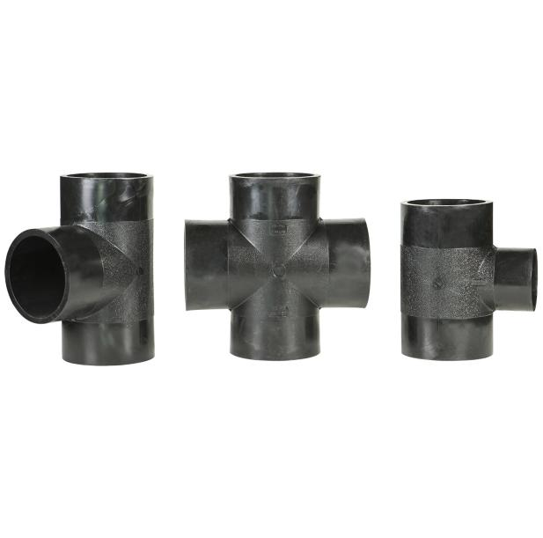

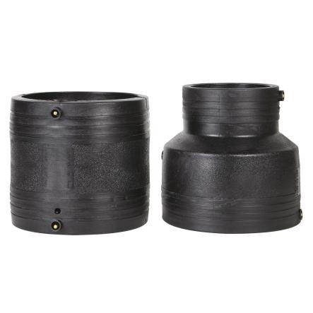
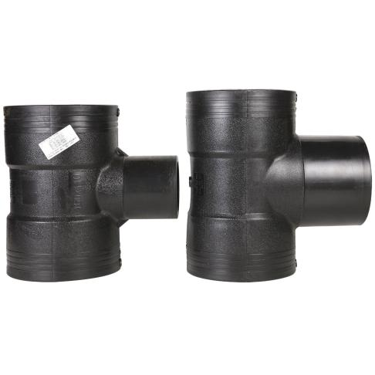
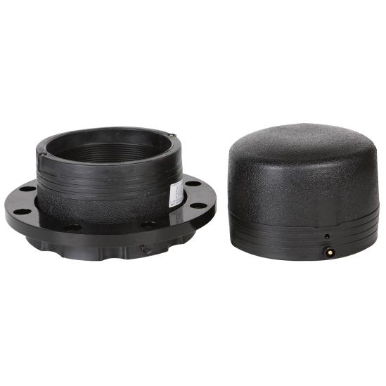
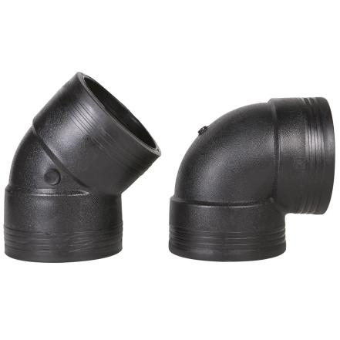
5.2Polyethylene Electro Fusion Fittings (PN10,PN16,PN20) SIZE dn25-dn800

* Pls confirm with manufacturer for other fittings and size.

- HDPE Double Wall Corrugate Pipe for Drainage (DWC)

INSIDE DIAMETER SERIES (mm)
Nominal size DN/ID | Minimum Mean inside diameter | Minimum laminated wall thickness | Socket length
100 | 95 | 1.0 | 32
150 | 145 | 1.3 | 43
200 | 196 | 1.5 | 54
300 | 295 | 2.0 | 64
400 | 392 | 2.5 | 74
500 | 490 | 3.0 | 85
600 | 592 | 3.5 | 96
800 | 783 | 4.5 | 118
1000 | 985 | 5.0 | 140
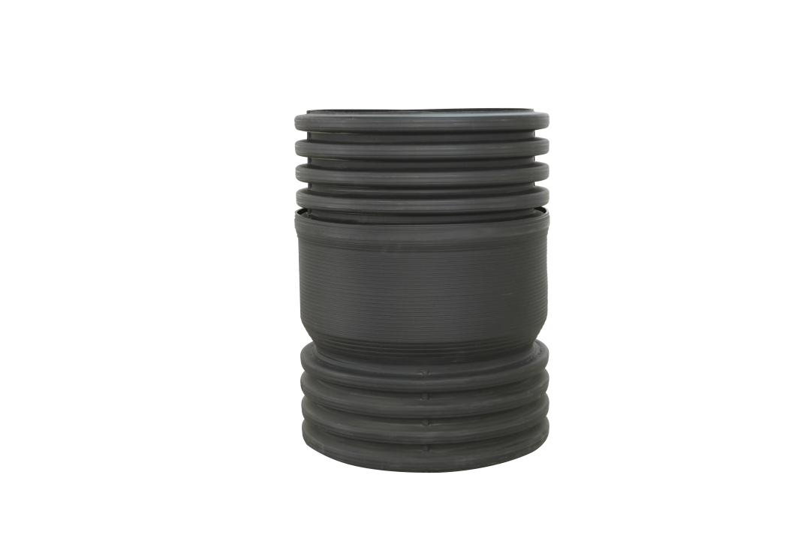

Material | Polyethylene PE100
Size (DN/ID) | DN100-DN1000
Ring Stiffness(SN) | SN4,SN6,SN8
Standard | GB/T19472.1,  EN13476-1
Length | 6m /pc

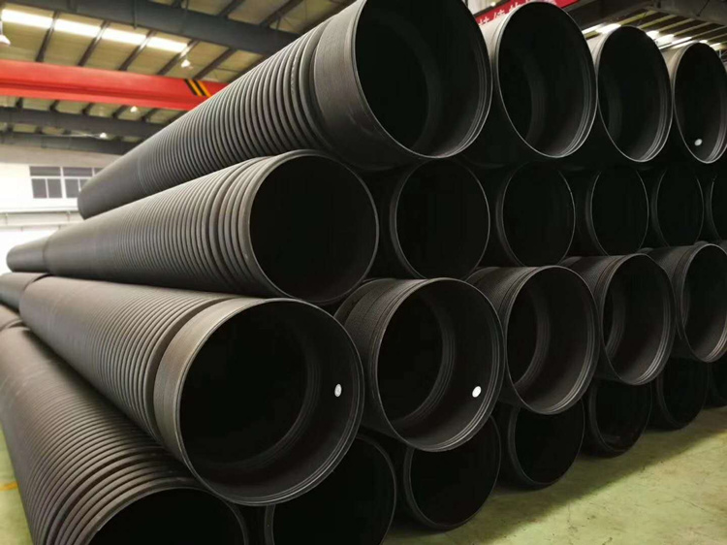
Features
DWC is a new type of pipe for outdoor drainage of buildings and municipal sewage,has a double wall sandwich construction consisting of a corrugated outer wall and a smooth inner wall. It has the advantages of light weight, small drainage resistance, high compressive strength, corrosion resistance and convenient construction. It is an ideal material to replace cast iron pipe and cement concrete pipe in municipal drainage projects.

- Metal Reinforced HDPE Spirally Corrugated Pipe for Underground Sewer (MRP)
INSIDE DIAMETER SERIES (mm)
Nominal size DN/ID | Minimum Mean inside diameter | Minimum laminated wall thickness | maximum pitch
300 | 294 | 4 | 75
400 | 392 | 4.5 | 85
500 | 490 | 5 | 100
600 | 588 | 6 | 110
700 | 685 | 6 | 115
800 | 785 | 7.5 | 120
900 | 885 | 7.5 | 135
1000 | 985 | 8 | 150
1100 | 1085 | 8 | 165
1200 | 1185 | 8 | 180
1300 | 1285 | 8 | 210
1400 | 1385 | 8 | 210
1500 | 1485 | 8 | 220
1600 | 1585 | 9 | 230
1800 | 1785 | 9 | 230
2000 | 1985 | 9 | 235
2200 | 2185 | 9 | 235
2400 | 2385 | 10 | 235

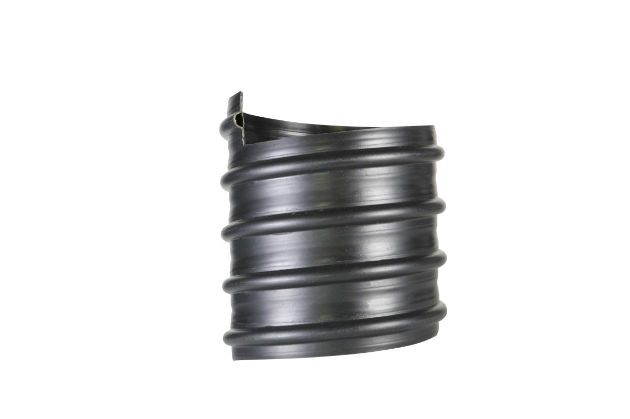

Material | Polyethylene PE100
Size (DN/ID) | Dn300-dn2400
Ring Stiffness(SN) | SN8,SN10,SN12.5,SN16
Standard | GB/T19472.1,  EN13476-1
Length | 6m,9m,12m

Features
MRP is a new type of plastic reinforced pipe for drainage systems,With polyethylene (PE) resin as the matrix, the adhesive resin coated steel strip is formed as the corrugated reinforcement as the main supporting structure, and the inner and outer polyethylene layers together with steel reinforcement integrate into the Steel Reinforced Spiral Corrugated Pipe.

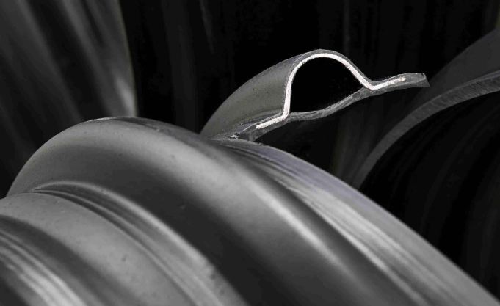
It has the advantages of flexible, corrosion-resistant, wear-resistant, with low frictional resistance and fast drainage speed etc, Widely used in municipal, industrial, agricultural, mining and other engineering drainage and sewage pipe networks, highway culverts, etc

- HDPE Spirally Enwound Structure-wall Pipe for Drainage TYPE B

INSIDE DIAMETER SERIES (mm)
Nominal size DN/ID | Minimum Mean inside diameter | Minimum wall thickness | Minimum length of fusion junction
300 | 294 | 2.0 | 59
400 | 392 | 2.5 | 59
500 | 490 | 3.0 | 59
600 | 588 | 3.5 | 59
700 | 673 | 4.0 | 59
800 | 785 | 4.5 | 59
900 | 885 | 5.0 | 59
1000 | 985 | 5.0 | 59
1100 | 1085 | 5.0 | 59
1200 | 1185 | 5.0 | 59
1300 | 1285 | 5.0 | 59
1400 | 1385 | 5.0 | 59
1500 | 1485 | 5.0 | 59
1600 | 1585 | 5.5 | 59
1700 | 1685 | 5.5 | 59
1800 | 1785 | 6.0 | 59
2000 | 1985 | 6.0 | 59
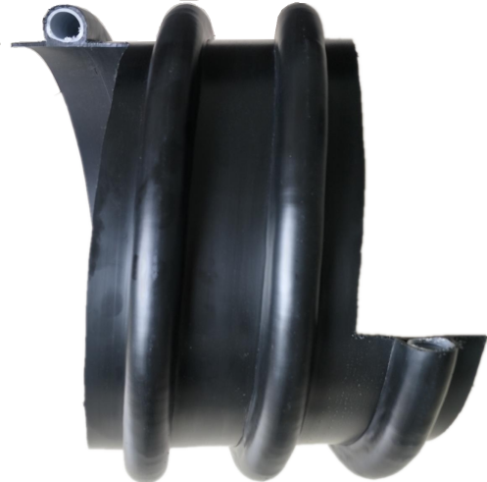

Material | Polyethylene PE100
Size (DN/ID) | Dn200-dn2000
Ring Stiffness(SN) | SN4,SN6,SN8,SN10,SN12.5,SN16
Standard | GB/T19472.2  EN13476-1,  DN16961
Length | 6m

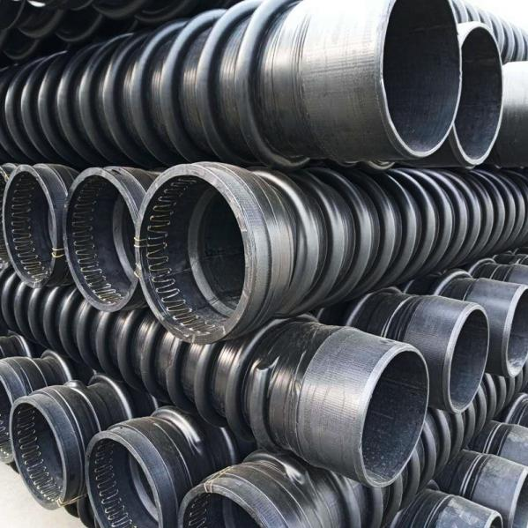
Features
Type B tube is an environmentally safe product with advantages such as light weight, strong pressure bearing capacity, high interface quality, long service life, corrosion resistance, high ring stiffness, and convenient construction. It is widely used in urban water supply, drainage, long-distance water transportation, and agricultural irrigation projects.

- PVC-U Pressure Pipe and Fittings for Water Supply

Nominal outside Diameter | Pipe Series S ,SDR and PN
Nominal outside Diameter | S16 | S12.5 | S10 | S8 | S6.3 | S5 | S4
Nominal outside Diameter | SDR33 | SDR26 | SDR21 | SDR17 | SDR13.6 | SDR11 | SDR9
dn | PN6.3 | PN8 | PN10 | PN12.5 | PN16 | PN20 | PN25
 | Nominal wall thickness
20 | - | - | - | - | - | 2 | 2.3
25 | - | - | - | - | 2 | 2.3 | 2.8
32 | - | - | - | 2 | 2.4 | 2.9 | 3.6
40 | - | - | 2 | 2.4 | 3 | 3.7 | 4.5
50 | - | 2 | 2.4 | 3 | 3.7 | 4.6 | 5.6
63 | 2 | 2.5 | 3 | 3.8 | 4.7 | 5.8 | 7.1
75 | 2.3 | 2.9 | 3.6 | 4.5 | 5.6 | 6.9 | 8.4
90 | 2.8 | 3.5 | 4.3 | 5.4 | 6.7 | 8.2 | 10.1
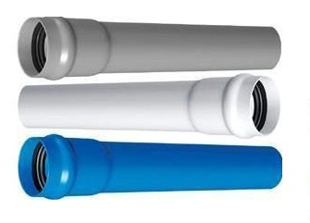
Material | PVC-U
Size (DN) | Dn20-dn1000
Pressure(PN) | PN6.3-PN25
Standard | GB/T10002.1,ISO4422,
Length | 4m or 6m/pc,  as per customers
Nominal outside Diameter | S20 | S16 | S12.5 | S10 | S8 | S6.3 | S5
Nominal outside Diameter | SDR41 | SDR33 | SDR26 | SDR21 | SDR17 | SDR13.6 | SDR11
Nominal outside Diameter | PN0.63 | PN0.8 | PN1.0 | PN1.25 | PN1.6 | PN2.0 | PN2.5
110 | 2.7 | 3.4 | 4.2 | 5.3 | 6.6 | 8.1 | 10
125 | 3.1 | 3.9 | 4.8 | 6 | 7.4 | 9.2 | 11.4
140 | 3.5 | 4.3 | 5.4 | 6.7 | 8.3 | 10.3 | 12.7
160 | 4 | 4.9 | 6.2 | 7.7 | 9.5 | 11.8 | 14.6
180 | 4.4 | 5.5 | 6.9 | 8.6 | 10.7 | 13.3 | 16.4
200 | 4.9 | 6.2 | 7.7 | 9.6 | 11.9 | 16.6 | 18.2
225 | 5.5 | 6.9 | 8.6 | 10.8 | 13.4 | 18.4 | -
250 | 6.2 | 7.7 | 9.6 | 11.9 | 14.8 | 20.6 | -
280 | 6.9 | 8.6 | 10.7 | 13.4 | 16.6 | 23.2 | -
315 | 7.7 | 9.7 | 12.1 | 15 | 18.7 | 26.1 | -
355 | 8.7 | 10.9 | 13.6 | 16.9 | 21.1 | 29.4 | -
400 | 9.8 | 12.3 | 15.3 | 19.1 | 23.7 | 33.1 | -
450 | 11 | 13.8 | 17.2 | 21.5 | 26.7 | 36.8 | -
500 | 12.3 | 15.3 | 19.1 | 23.9 | 29.7 | - | -
560 | 13.7 | 17.2 | 21.4 | 26.7 | - | - | -
630 | 15.4 | 19.3 | 24.1 | 30 | - | - | -
710 | 17.4 | 21.8 | 27.2 | - | - | - | -
800 | 19.6 | 24.5 | 30.6 | - | - | - | -
900 | 22.0 | 27.6 | - | - | - | - | -
1000 | 24.5 | 30.6 | - | - | - | - | -
Dn=OD

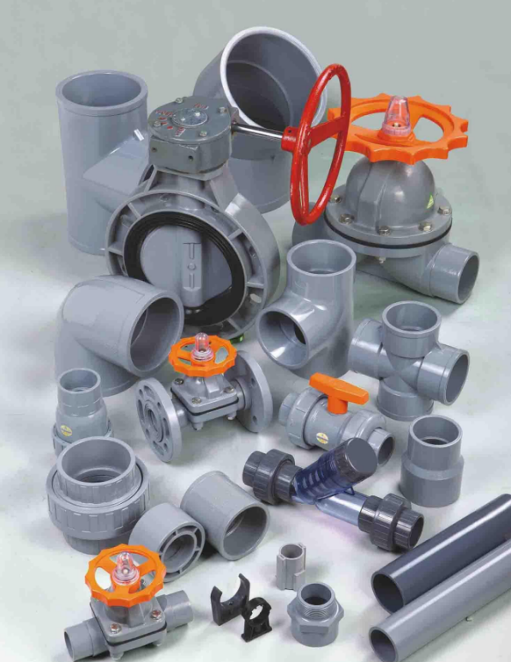

- PVC-U pipe and Fittings for Sewerage inside building

Nominal outside diameter | Wall thickness
Pipes for inside building (mm)
50 | 2.0
75 | 2.3
110 | 3.2
160 | 4.0
200 | 4.9
250 | 6.2
315 | 7.8
Pipes for non-pressure buried drainage SDR51 SN2
315 | 6.2
355 | 7.0
400 | 7.9
450 | 8.8
500 | 9.8
630 | 12.3
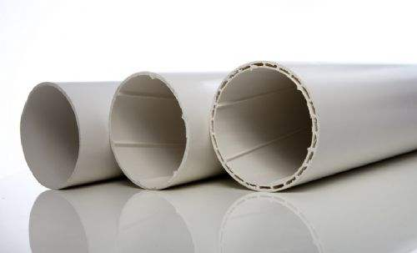

Material | PVC-U
Size (DN) | Dn50-dn630
Ring stiffness(SN) | SN2,SN4,SN8
Standard | GB/T5836.1,GB/T20221,  ISO3633, ISO4435
Length | 4m or 6m/pc,  as per customers

Dn=OD

Features
PVC-U drainage pipes have advantages such as long service life and corrosion resistance that cast iron pipes cannot match; In terms of construction, it has the characteristics of being lightweight, easy to transport and install, and easy to connect. It is widely used in civil building drainage and sewage, chemical drainage and sewage, rainwater drainage and other fields

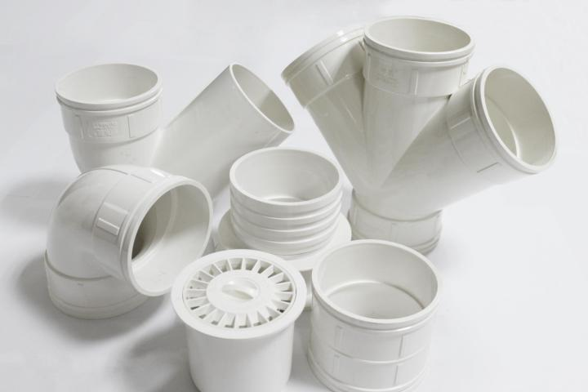

- PPR Pipe and Fittings for Hot and Cold Water

Pipe series S | S5 | S4 | S3.2
PN bar | （mm）PN12.5 | PN16 | PN20
Water | Cold water | Cold water | Hot water
DN/OD | Wall thickness en(mm)
20 | 2.0 | 2.3 | 2.8
25 | 2.3 | 2.8 | 3.5
32 | 2.9 | 3.6 | 4.4
40 | 3.7 | 4.5 | 5.5
50 | 4.6 | 5.6 | 6.9
63 | 5.8 | 7.1 | 8.6
75 | 6.8 | 8.4 | 10.3
90 | 8.2 | 10.1 | 12.3
110 | 10.0 | 12.3 | 15.1
125 | 11.4 | 14.0 | 17.1
140 | 12.7 | 15.7 | 19.2
160 | 14.6 | 17.9 | 21.9
180 | 16.4 | 20.1 | 24.6
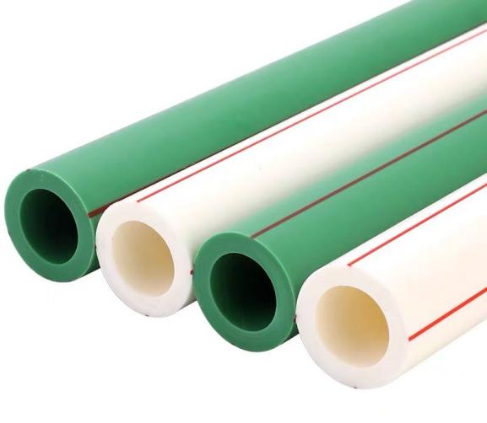
Material | Polypropylene (PPR)
Size (DN) | Dn20-dn160mm
Pressure(PN) | PN12.5,PN16,PN20
Standard | GB/T18742.2,  ISO 15874-2
Length | 4m/pc
Dn=OD

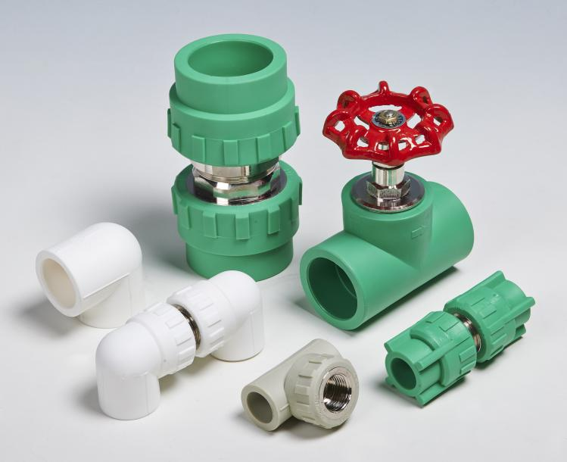
Features
PP-R pipes & fittings PP has the advantages of heat resistance, pressure resistance, thermal insulation, energy saving, long service life, and economy, and is widely used in cold and hot water supply, heating systems, and liquid transportation in the food industry The outstanding temperature rating up to 95℃ and pressure rating up to 25 Bar.

- PE-RT Pipe and Fittings for Underfloor Heating Systems

Nominal Pressure  PN(Series) | Nominal diameter  DN (mm) | Wall thickness  en(mm)
PN12.5 (S5) | 16 | 1.8
PN12.5 (S5) | 20 | 2.0
PN12.5 (S5) | 25 | 2.3
PN12.5 (S5) | 32 | 2.9
PN12.5 (S5) | 40 | 3.7
PN16 (S4) | 16 | 2.0
PN16 (S4) | 20 | 2.3
PN16 (S4) | 25 | 2.8
PN16 (S4) | 32 | 3.6
PN16 (S4) | 40 | 4.5
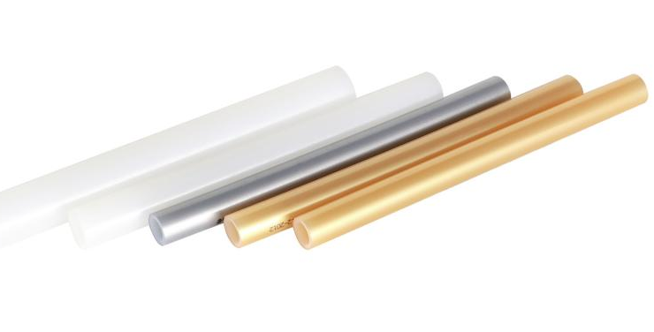

Material | PE-RT
Size (DN) | Dn16-dn40mm
Pressure(PN) | PN12.5,PN16,
Standard | GB/T 28799.2,  ISO 22391
Length | 300m/Coil

DN=OD

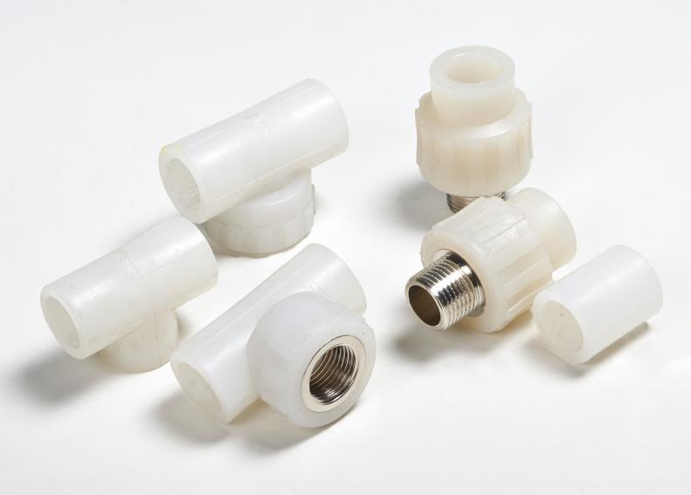
Features
PE-RT pipe not only retains the good flexibility, high thermal conductivity, and inertness of PE pipes, but also improves their pressure resistance, making them suitable for long-term use in hot water transportation below 60 ℃. It retains the good flexibility and inertness of PE pipe, as well as low temperature resistance (-40 ℃), good impact resistance, and better pressure resistance. It is non-toxic, odorless, pollution-free and recyclable. Widely used in ground heating systems and building hot and cold water supply.

- CPVC Pipe for High-voltage Power Cable Protection

Specification | Wall thickness
Φ50 | 2.5
Φ75 | 3
Φ90 | 3
Φ90 | 4
Φ110 | 4
Φ110 | 5
Φ125 | 4
Φ125 | 5
Φ139 | 4
Φ139 | 5
Φ160 | 4
Φ160 | 5
Φ160 | 6
Φ160 | 8
Φ167 | 6
Φ167 | 8
Φ192 | 6
Φ192 | 8
Φ200 | 6
Φ200 | 8
Φ219 | 9
Φ225 | 10
Φ250 | 11
Φ250 | 12
Other thickness can be discussed
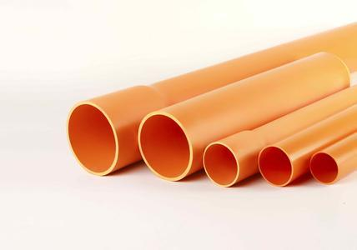

Material | PVC-C
Size (DN) | Dn50-dn250 mm
Ring Stiffness(SN) | SN4,SN8
Standard | QB/T2479
Length | 5.8m/pc

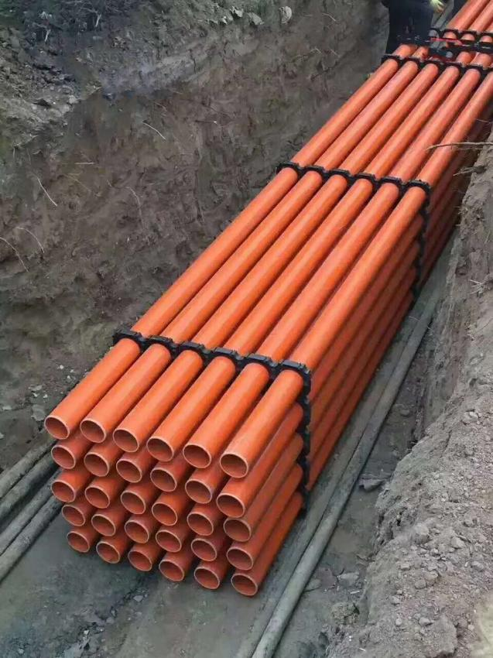

Features
CPVC is similar to PVC in resistance to fire. It is typically very difficult to ignite and tends to self-extinguish an it is ideally suited for self-supporting constructions where temperatures up to 200 °F (93 °C) ,can withstand high voltage of over 30000 volts

- MPP Pipe for High-voltage Power Cable Protection

Specification  （OD） | Wall thickness (mm)
Φ110 | 5
Φ110 | 6
Φ110 | 8
Φ125 | 6
Φ125 | 8
Φ140 | 6
Φ140 | 8
Φ160 | 6
Φ160 | 8
Φ160 | 10
Φ167 | 6
Φ167 | 8
Φ167 | 10
Φ180 | 6
Φ180 | 8
Φ180 | 10
Φ180 | 12
Φ192 | 8
Φ192 | 10
Φ192 | 12
Φ200 | 8
Φ200 | 10
Φ200 | 12
Φ225 | 10
Φ225 | 12
Φ225 | 15
Φ250 | 10
Φ250 | 12
Φ250 | 16
Φ315 | 12
Φ315 | 16
Other thickness can be discussed
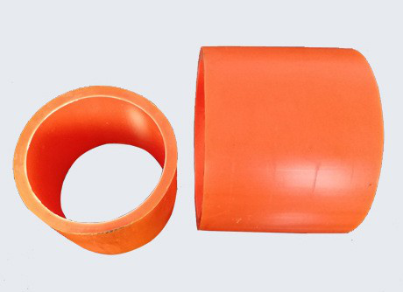

Material | Polypropylene
Size (DN) | Dn50-dn315mm
Ring Stiffness(SN) | SN8-SN40
Standard | DL/T802.7
Length | 6m,or 12m/pc

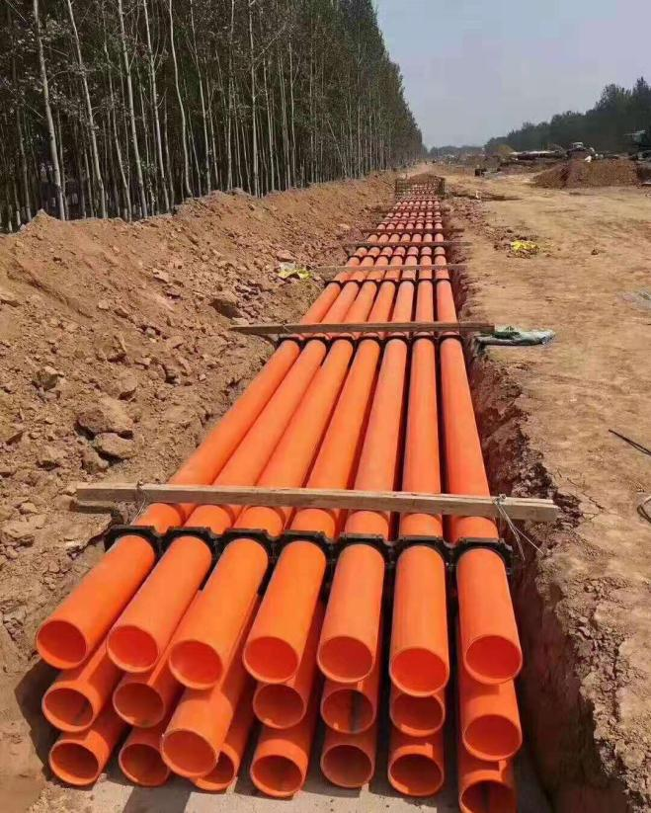
Features
MPP pipes use modified polypropylene as the main raw material. It has the characteristics of high temperature resistance and external pressure resistance, and is suitable for cable conduit pipes of high-voltage transmission lines above 10KV. MPP is divided into excavation type and trenchless type.

- HDPE Double wall & Single Wall Corrugated Pipes for Power & Telecom

Specification  DN（mm) | Type | OD(mm) | ID(mm)
16,20,25,32 | Single wall
50 | Single&double | 50 | 40
60 | Single wall | 60 | 53
63 | Single wall | 63 | 50
75 | Single&double | 75 | 60
90 | Single&double | 90 | 80
110 | Single&double | 110 | 95
116 | Single&double | 116 | 100
160 | Double wall | 160 | 145
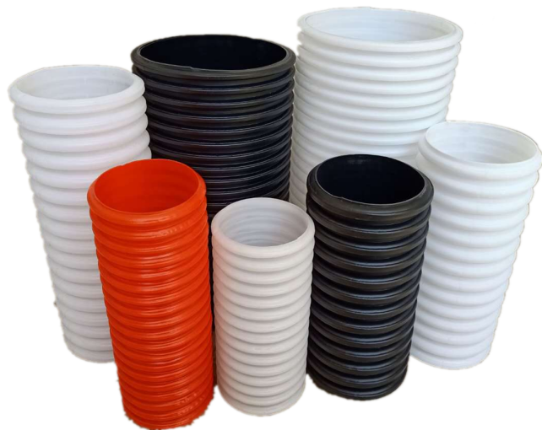
Material | PE100
Size (DN) | Dn16-dn160 mm
Ring Stiffness(SN) | SN4,SN6,S8,SN10
Standard | YD/T841.3
Length | 6m/pc,20-100m/coil
Features
PE Single wall or double wall corrugated pipes,their superior electrical superior electrical insulation makes them suitable for use as protective conduits for wires and cables.

Perforated pipes are also widely used as permeable drainage pipes in farmland,golf course, mines, landfills, and other places.excavation type.

- HDPE Silicore Plastic Pipe (PLB HDPE DUCT)

SIZE  (DN) | mean outer diameter/mm |  | Nominal wall thickness
SIZE  (DN) | norminal | tolerance | (mm)
32/26 | 32 | +0.3 | 2.5
34/28 | 34 | +0.3 | 3
40/33 | 40 | +0.4 | 3.5
46/38 | 46 | +0.4 | 4
50/41 | 50 | +0.5 | 4.5
63/54 | 63 | +0.6 | 5
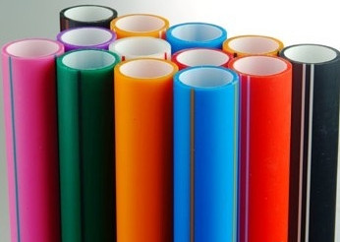

Material | PE100
Size (DN) | Dn32-dn63 mm
Standard | GB/T24456
Length | 500-3000m/coil
Features
HDPE SiliCore Plastic Duct is permanently Lubricant High-Density Polyethylene (PLB HDPE) duct. PLB duct has two concentric layers,the outer layer is made of HDPE material and the inner layer of solid permanent lubricant,it is suitable for underground fiber optic cable installation by blowing as well as conventional pulling.

- PVC Conduit for Wire Casing in Building

Nominal Size  Dn=OD | Minimum  Wall thickness
16 | 1.0
20 | 1.1
25 | 1.3
32 | 1.5
40 | 1.9
50 | 2.2
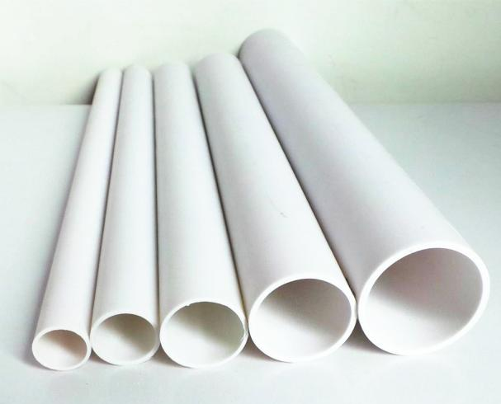
Features
Excellent cold bending performance, high compressive strength, flame retardant insulation, moisture and corrosion resistance.Widely used for wire conduit protection in home indoor buildings.
Material | PVC
Size (DN) | Dn16-dn50 mm
Standard | JG/T3050
Length | 3m/PC

- PE Conduit for Wire Casing
Nominal Size  Dn=OD | Minimum  Wall thickness
20 | 1.4-2.3
25 | 1.5-2.3
32 | 1.8-3.0
40 | 1.8-3.0

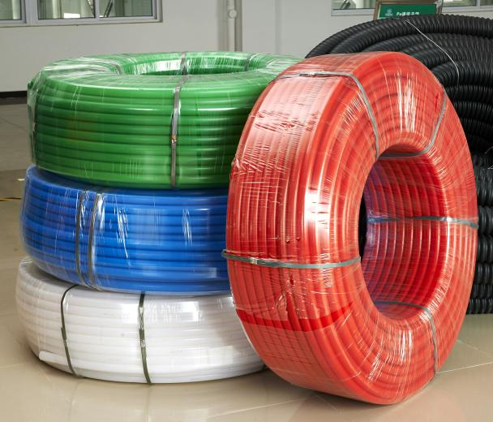
Features
Suitable for buried underground, used for the protection of fiber optic cables, as well as for the conduit, isolation, and protection of urban communication optical cables,TV network lines, and indoor cables in buildings.
Material | PE100
Size (DN) | Dn20-dn40 mm
Standard | YD/T841.2
Length | 100-300m/coil

- PE Plum Blossom Pipe for buried telecom conduit
Type | Outside diameter  OD(mm) | Sub-pipe Inside diameter ID(mm)
5 holes | 94 | 28
7 holes | 110 | 32
9 holes | 115 | 32
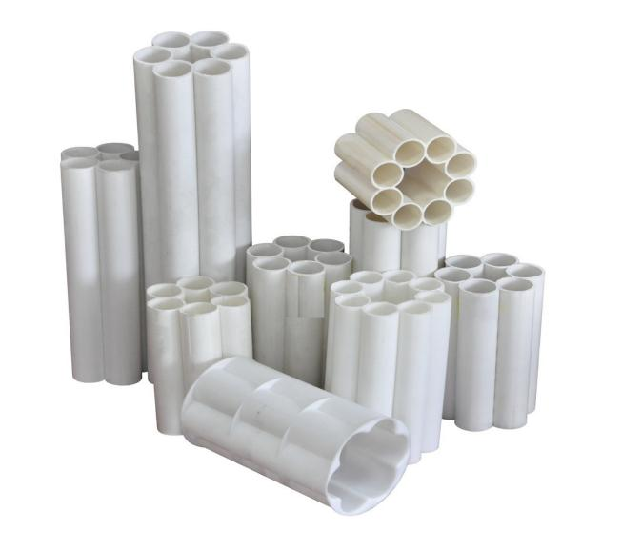
Material | PE100
Size (DN) | 5,7,9 holes
Standard | YD/T841.5
Length | 6m/pc,100m/coil
Features
Multi hole casing with intersecting single hole walls and integral forming, waterproof, moisture-proof, anti-aging, long service life and good weather resistance, used for communication cable casing.

- PVC multi-hole Pipe for buried telecom conduit

Type | Outside diameter  OD(mm) | Sub-pipe Inside diameter ID(mm)
1 holes | 92 | 1-86
4 holes | 107 | 4-50
5 holes | 107 | 5-33
6 holes | 107 | 6-33
9 holes | 107 | 9-33
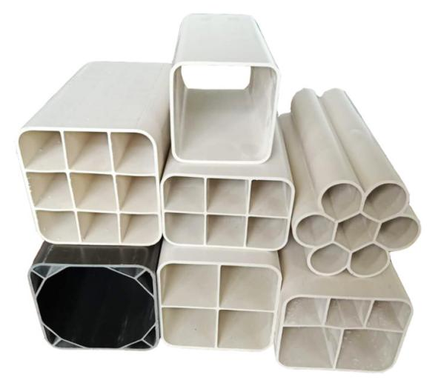
Features
PVC multi-hole Pipe has multiple hole positions, which are easy to construct and can directly thread cables. At the same time, pipe holes can be reserved to improve the utilization rate of communication hole positions.
Material | PVC
Size (DN) | 1,4,5,6,9 holes
Standard | YD/T1324
Length | 6m/pc

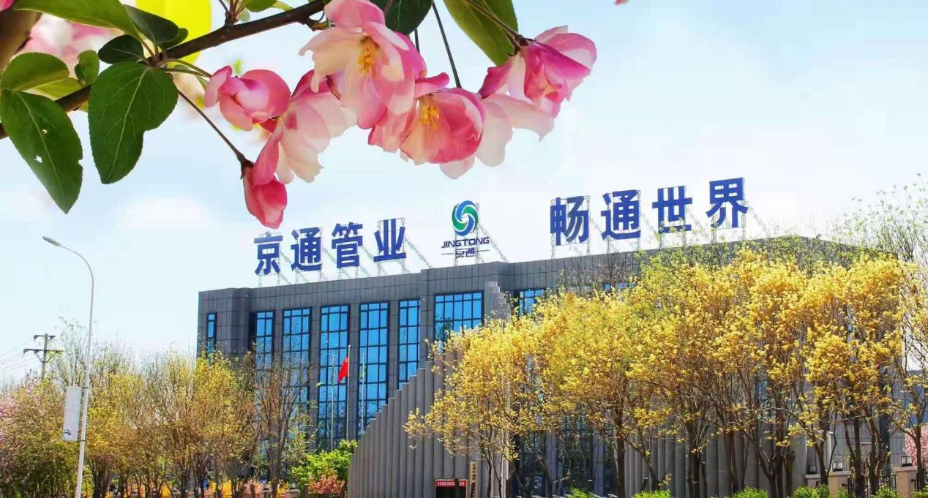

Tianjin Jingtong Pipeline Technology Co.,Ltd.
Headquarters address：No.7,Chaoyang East Road,Baodi Plastic Product Industrial Area,
Tianjin,China 301800
Tel：+8613512272372 Wechat：13512272372 WhatsApp：+8613512272372
Website：www.cn-pipes.com
Email：cnpipes2026@163.com

