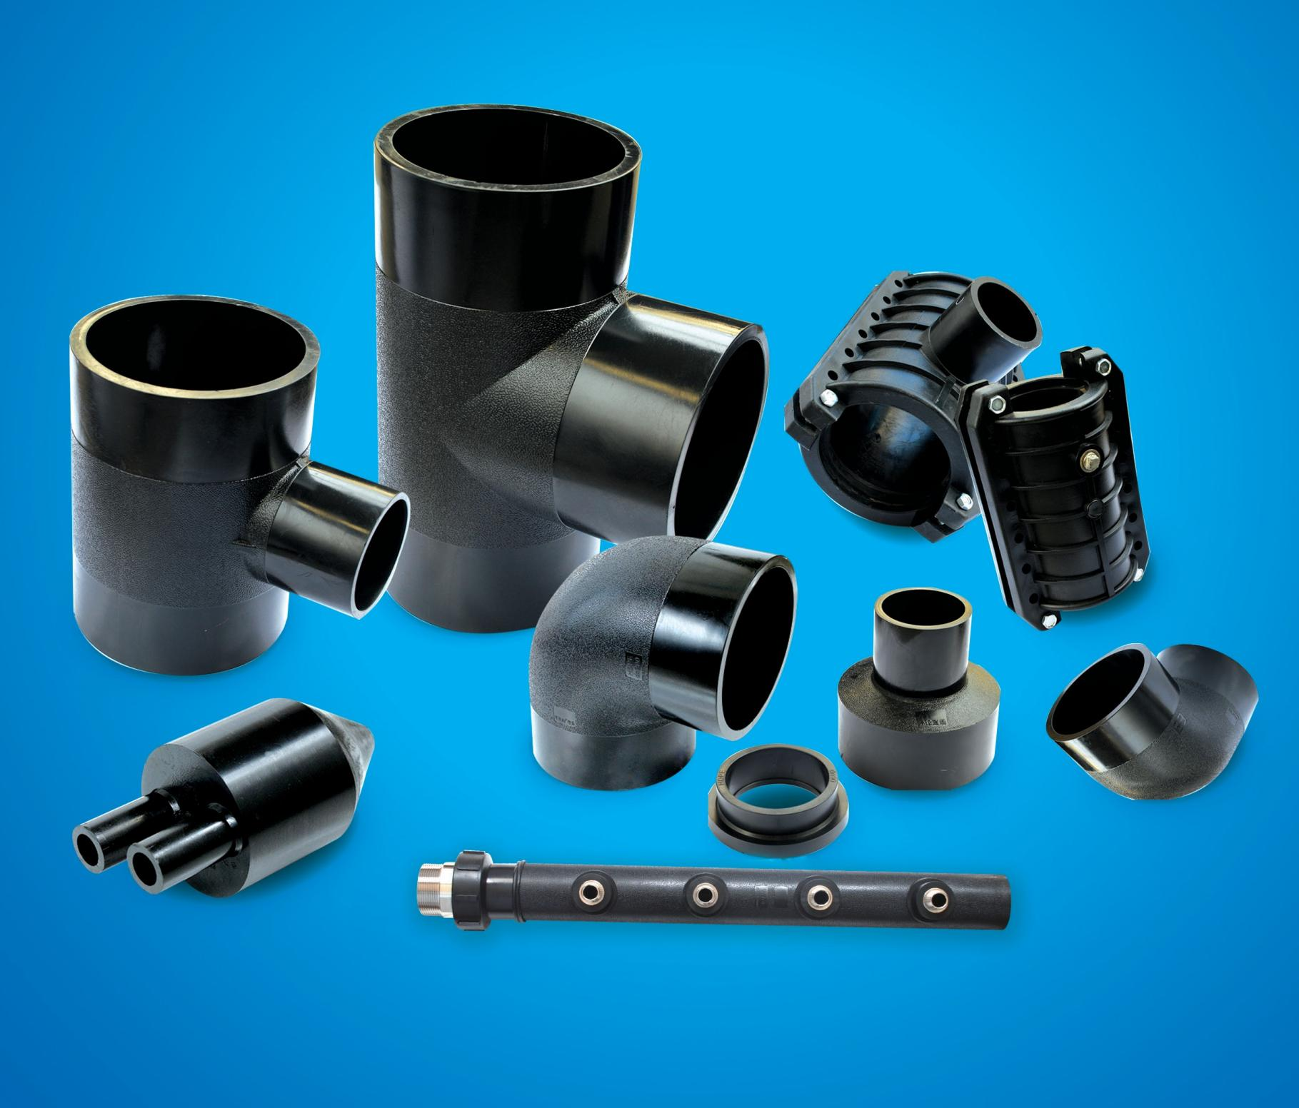
HDPE 给水管件

天津京通管道科技股份有限公司
Tianjin Jingtong Pipeline Technology Co.,Ltd.



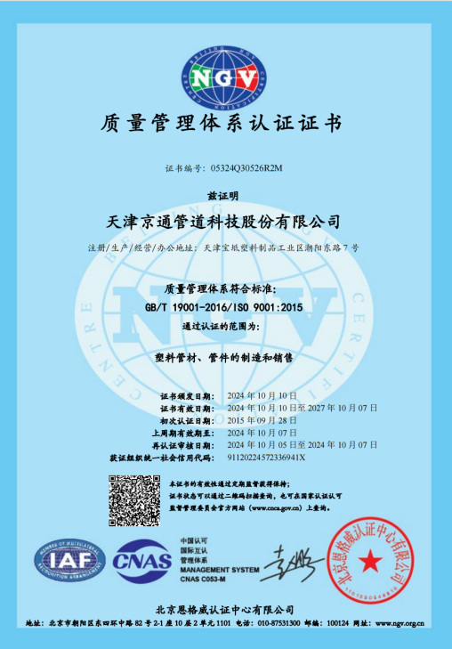 | 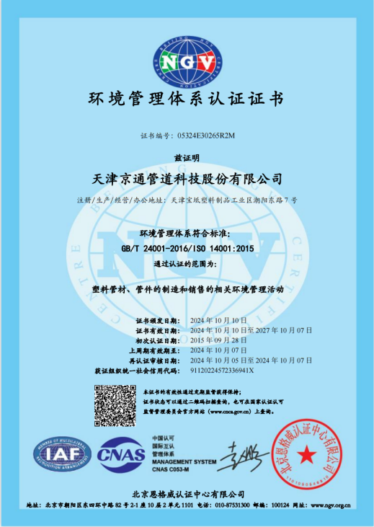 |  | 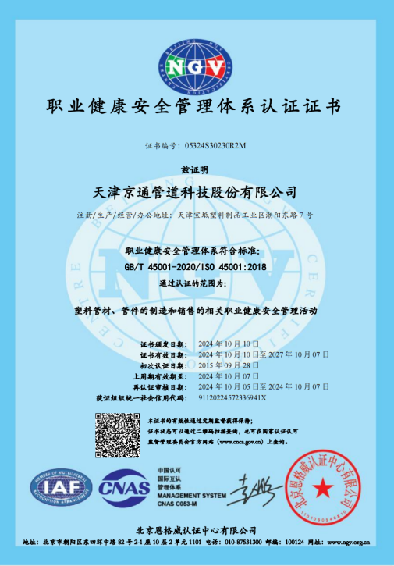
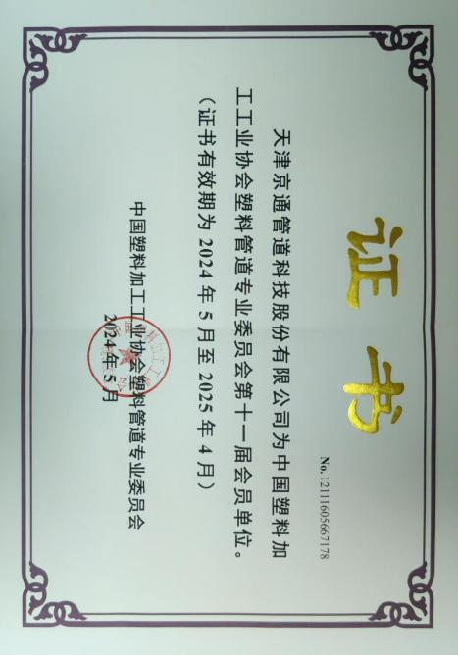 | 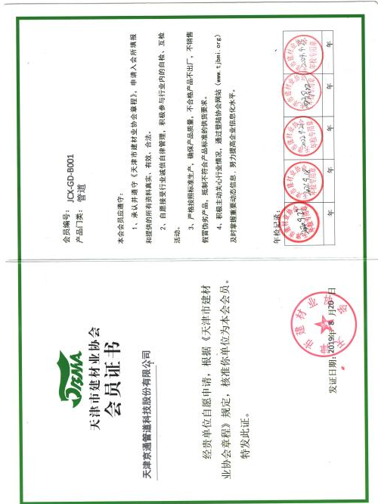 |  | 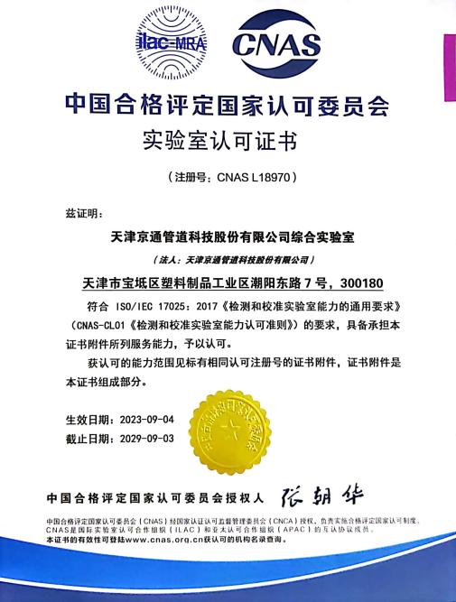
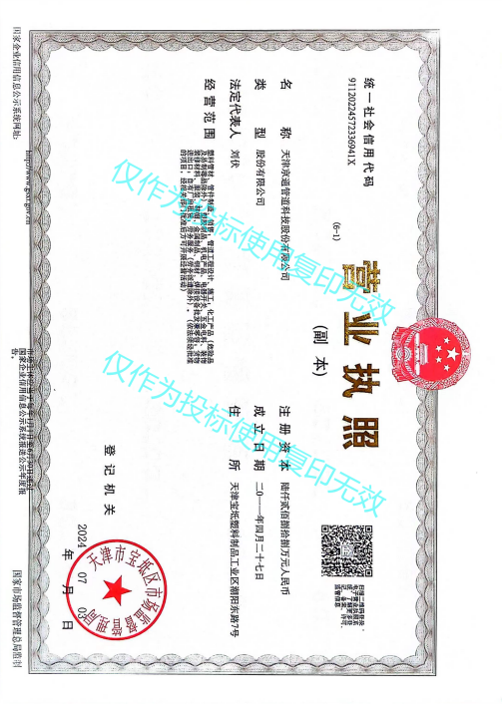 |  | 


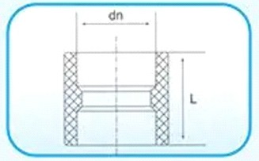
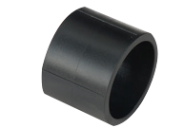
热熔承插直通

编码 | 规格 dn | L
 | dn20 | 31
 | dn25 | 34
 | dn32 | 39
 | dn40 | 43
 | dn50 | 49
 | dn63 | 57
 | dn75 | 63
 | dn90 | 67
 | dn110 | 74


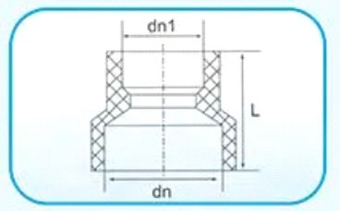
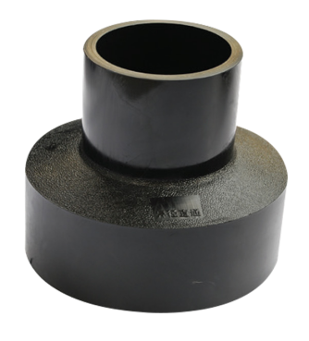
热熔承插异径直通

编码 | 规格 dn | L
 | dn25X20 | 33
 | dn32X20 | 34
 | dn32X25 | 37
 | dn40X20 | 40
 | dn40X25 | 40
 | dn40X32 | 42
 | dn50X20 | 40
 | dn50X25 | 44
 | dn50X32 | 45
 | dn50X40 | 48
 | dn63X20 | 45
 | dn63X25 | 46
 | dn63X32 | 49
 | dn63X40 | 50
 | dn63X50 | 55
 | dn75X32 | 65
 | dn75X40 | 65
 | dn75X50 | 65
 | dn75X63 | 65
 | dn90X40 | 71
 | dn90X50 | 71
 | dn90X63 | 71
 | dn90X75 | 71
 | dn110X50 | 76
 | dn110X63 | 78
 | dn110X75 | 79
 | dn110X90 | 76

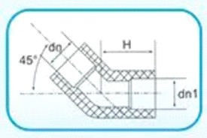
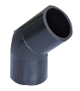
热熔承插 45°弯头

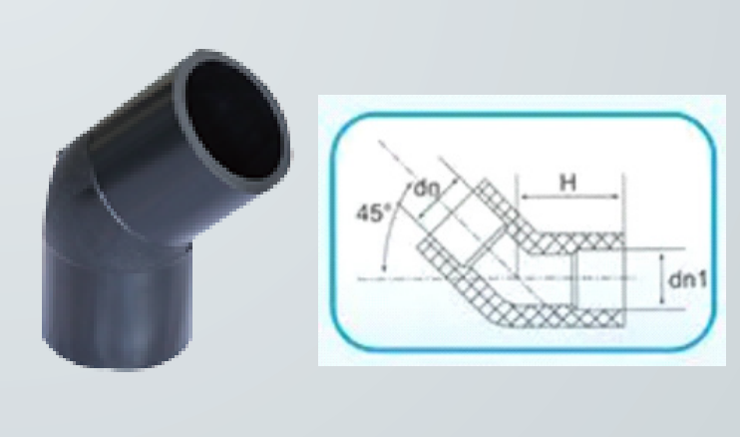   | 编码 | 规格 dn | H
 |  | dn20 | 22
 |  | dn25 | 25
 |  | dn32 | 30
 |  | dn40 | 34
 |  | dn50 | 39
 |  | dn63 | 45
 |  | dn75 | 58
 |  | dn90 | 63
 |  | dn110 | 70

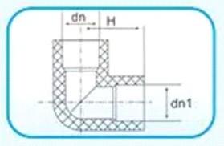
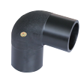
热熔承插 90°弯头

 | 编码 | 规格 dn | H
 |  | dn20 | 23
 |  | dn25 | 25
 |  | dn32 | 32
 |  | dn40 | 40
 |  | dn50 | 45
 |  | dn63 | 57
 |  | dn75 | 67
 |  | dn90 | 74
 |  | dn110 | 85


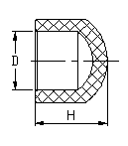
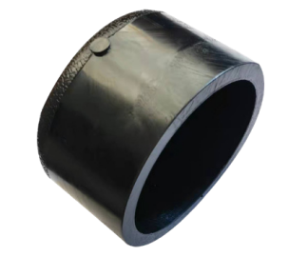
热熔承插堵帽

 | 编码 | 规格 dn | H
 |  | dn20 | 22
 |  | dn25 | 27
 |  | dn32 | 27
 |  | dn40 | 29
 |  | dn50 | 40
 |  | dn63 | 41
 |  | dn75 | 44
 |  | dn90 | 50
 |  | dn110 | 58

热熔承插异径三通

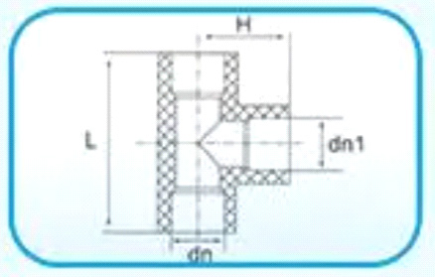  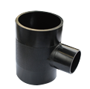   | 编码 | 规格 dn | L | H
 |  | dn25X20 | 52 | 26
 |  | dn32X20 | 57 | 30
 |  | dn32X25 | 62 | 34
 |  | dn40X20 | 61 | 32
 |  | dn40X25 | 66 | 35
 |  | dn40X32 | 74 | 38
 |  | dn50X20 | 67 | 39
 |  | dn50X25 | 72 | 40
 |  | dn50X32 | 80 | 42
 |  | dn50X40 | 87 | 47
 |  | dn63X20 | 75 | 45
 |  | dn63X25 | 80 | 46
 |  | dn63X32 | 87 | 49
 |  | dn63X40 | 98 | 52
 |  | dn63X50 | 103 | 54
 |  | dn75X20 | 82 | 52
 |  | dn75X25 | 85 | 54
 |  | dn75X32 | 96 | 56
 |  | dn75X40 | 111 | 60
 |  | dn75X50 | 111 | 62
 |  | dn75X63 | 125 | 66
 |  | dn90X25 | 100 | 65
 |  | dn90X32 | 98 | 64
 |  | dn90X40 | 105 | 66
 |  | dn90X50 | 115 | 69
 |  | dn90X63 | 127 | 74
 |  | dn90X75 | 140 | 76
 |  | dn110X25 | 110 | 75
 |  | dn110X32 | 110 | 75
 |  | dn110X40 | 115 | 78
 |  | dn110X50 | 123 | 82
 |  | dn110X63 | 135 | 84
 |  | dn110X75 | 147 | 86
 |  | dn110X90 | 162 | 88


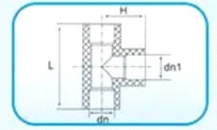
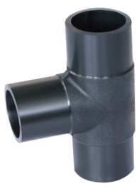
热熔承插等径三通

编码 | 规格 dn | L | H
 | dn20 | 49 | 25
 | dn25 | 52 | 27
 | dn32 | 68 | 39
 | dn40 | 82 | 40
 | dn50 | 95 | 45
 | dn63 | 116 | 58
 | dn75 | 135 | 68
 | dn90 | 153 | 78
 | dn110 | 181 | 91


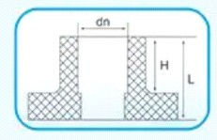
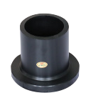
热熔承插法兰头

编码 | 规格 dn | L | H
 | dn50 | 23 | 11
 | dn63 | 35 | 19
 | dn75 | 32 | 21
 | dn90 | 40 | 22
 | dn110 | 45 | 26


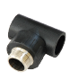
外螺纹三通

编码 | 规格 dn | L | H
 | dn20X1/2" | 52 | 43
 | dn25X1/2"
 | dn25X3/4 〃 | 60 | 50
 | dn32X1/2"
 | dn32X3/4"
 | dn32X 1" | 71 | 59

内螺纹三通

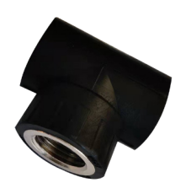  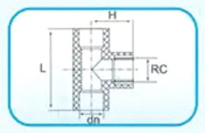   | 编码 | 规格 dn | L | H
 |  | dn20X1/2 〃 | 51 | 31
 |  | dn25X1/2 〃 | 51 | 33
 |  | dn25X3/4 〃 | 60 | 35
 |  | dn32X1/2 〃
 |  | dn32X3/4" | 60 | 38
 |  | dn32X 1" | 72 | 42

内螺纹 90°弯头

 | 编码 | 规格 dn | H | H1
 |  | dn20X1/2" | 31 | 26
 |  | dn25X1/2" | 33 | 26
 |  | dn25X3/4 〃 | 35 | 30
 |  | dn32X1/2"
 |  | dn32X3/4" | 38 | 30
 |  | dn32X 1" | 43 | 36

外螺纹 90°弯头

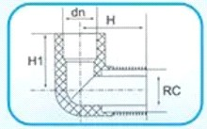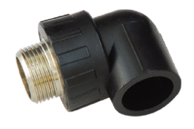 | 编码 | 规格 dn | H | H1
 |  | dn20X1/2" | 43 | 25
 |  | dn20X3/4"
 |  | dn25X1/2" | 46 | 26
 |  | dn25X3/4" | 49 | 30
 |  | dn32X1/2"
 |  | dn32X3/4" | 53 | 31
 |  | dn32X1" | 60 | 36


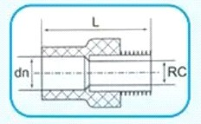
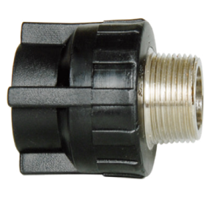
外螺纹直通

编码 | 规格 dn | L
 | dn20X1/2" | 49
 | dn25X1/2" | 53
 | dn25X3/4" | 53
 | dn32X1/2"
 | dn32X3/4" | 57
 | dn32X1" | 65
 | dn40X1-1/4" | 74
 | dn50X1-1/2" | 78
 | dn63X2 〃 | 85
 | dn75X5/2 〃 | 96
 | dn90X3 〃 | 108
 | dn110X4 〃 | 125


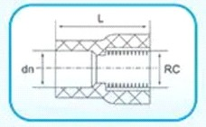
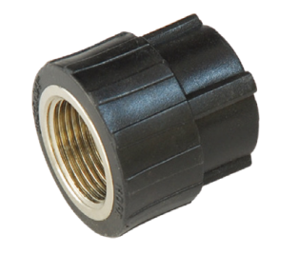
内螺纹直通

编码 | 规格 dn | L
 | dn20X1/2" | 37
 | dn25X1/2" | 41
 | dn25X3/4" | 41
 | dn32X1/2"
 | dn32X3/4" | 44
 | dn32X1" | 48
 | dn40X 1-1/4" | 54
 | dn50X 1-1/2" | 58
 | dn63X2 〃 | 63
 | dn75X5/2 〃 | 74
 | dn90X3 〃 | 90
 | dn110X4 〃 | 106


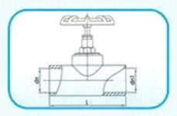
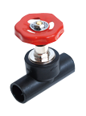
截止阀

编码 | 规格 dn | L
 | dn20 | 65
 | dn25 | 80
 | dn32 | 84
 | dn40 | 106
 | dn50 | 111
 | dn63 | 122


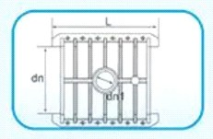
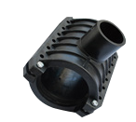
增接口

编码 | 规格 dn | L
 | dn110X63 | 145
 | dn110X75 | 145
 | dn110x90 | 145
 | dn160x63 | 170
 | dn160x75 | 170
 | dn160x90 | 170
 | dn160x110 | 170
 | dn200x63 | 228
 | dn200x75 | 228
 | dn200x90 | 228
 | dn200x110 | 228
 | dn200x160 | 228
 | dn250x110 | 270
 | dn250x160 | 270
 | dn250x200 | 270
 | dn315x110 | 335
 | dn315x160 | 335
 | dn315x2500 | 335
 | dn315x250 | 335


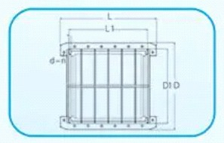
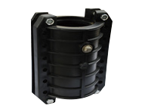
PE 抢修接

编码 | 规格 dn | L | L1 | D | D1 | d | n
 | dn63 | 220 | 160 | 145 | 96 | 15 | 10
 | dn75 | 223 | 175 | 168 | 118 | 15 | 10
 | dn90 | 314 | 252 | 188 | 136 | 15 | 12
 | dn110 | 340 | 275 | 215 | 160 | 15 | 12
 | dn125 | 355 | 290 | 228 | 178 | 15 | 12
 | dn160 | 370 | 305 | 270 | 215 | 15 | 12
 | dn200 | 415 | 340 | 312 | 252 | 15 | 14
 | dn225 | 438 | 355 | 355 | 295 | 15 | 14
 | dn250 | 480 | 405 | 378 | 314 | 15 | 16
 | dn315 | 510 | 430 | 480 | 410 | 15 | 16

热熔对接异径直通

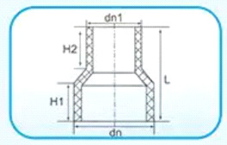  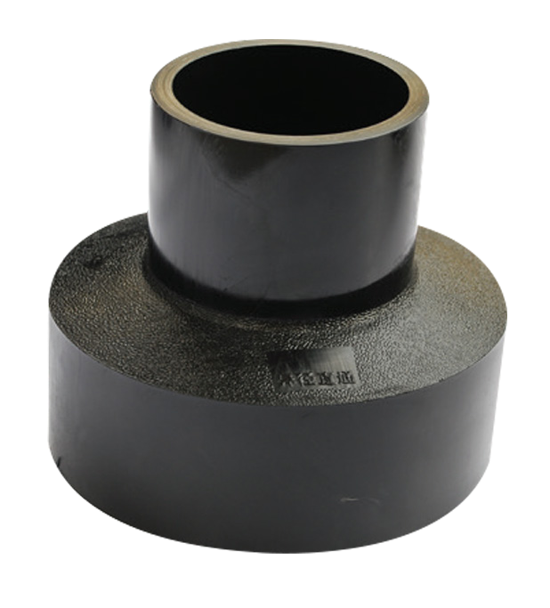   | 编码 | 规格 dn | H | H1 | H2
 |  | dn75X50 | 145 | 68 | 69
 |  | dn75X63 | 137 | 68 | 65
 |  | dn90X50 | 147 | 68 | 68
 |  | dn90X63 | 140 | 68 | 64
 |  | dn90X75 | 143 | 69 | 68
 |  | dn110X50 | 155 | 70 | 70
 |  | dn110X63 | 147 | 70 | 65
 |  | dn110X75 | 152 | 70 | 70
 |  | dn110X90 | 146 | 70 | 70
 |  | dn110X90 | 143 | 67 | 60
 |  | dn125X75 | 145 | 67 | 63
 |  | dn125X90 | 148 | 67 | 65
 |  | dn125X110 | 137 | 67 | 65
 |  | dn140X63 | 142 | 69 | 55
 |  | dn140X75 | 150 | 69 | 64
 |  | dn140X90 | 155 | 69 | 69
 |  | dn140X110 | 150 | 70 | 68
 |  | dn140X125 | 138 | 70 | 60
 |  | dn160X63 | 160 | 70 | 67
 |  | dn160X75 | 145 | 70 | 60
 |  | dn160X90 | 145 | 70 | 60
 |  | dn160X110 | 145 | 70 | 60
 |  | dn160X125 | 145 | 70 | 60
 |  | dn160X140 | 145 | 70 | 60
 |  | dn180X110 | 153 | 70 | 62
 |  | dn180X160 | 153 | 70 | 73
 |  | dn200X63 | 165 | 70 | 70
 |  | dn200X75 | 165 | 70 | 70
 |  | dn200X90 | 165 | 70 | 70
 |  | dn200X110 | 166 | 70 | 70
 |  | dn200X125 | 160 | 70 | 75
 |  | dn200X140 | 160 | 70 | 70
 |  | dn200X160 | 157 | 70 | 74
 |  | dn200X180 | 176 | 80 | 80
 |  | dn225X110 | 165 | 70 | 70
 |  | dn225X160 | 155 | 70 | 70
 |  | dn225X200 | 160 | 70 | 80
 |  | dn250X110 | 168 | 70 | 75
 |  | dn250X125 | 160 | 70 | 75
 |  | dn250X160 | 160 | 70 | 70

 | 编码 | 规格 dn | H | H1 | H2
 |  | dn250X200 | 150 | 70 | 70
 |  | dn250X225 | 16 | 70 | 90
 |  | dn280X110 | 180 | 80 | 65
 |  | dn280X160 | 175 | 80 | 70
 |  | dn280X200 | 175 | 80 | 85
 |  | dn280X250 | 160 | 80 | 65
 |  | dn315X110 | 185 | 80 | 65
 |  | dn315X160 | 180 | 80 | 70
 |  | dn315X180 | 180 | 80 | 75
 |  | dn315X200 | 185 | 80 | 70
 |  | dn315X225 | 180 | 80 | 80
 |  | dn315X250 | 175 | 80 | 80
 |  | dn315X280 | 175 | 80 | 80
 |  | dn355X110 | 190 | 80 | 60
 |  | dn355X160 | 195 | 80 | 70
 |  | dn355X200 | 175 | 80 | 60
 |  | dn355X250 | 175 | 80 | 70
 |  | dn355X315 | 170 | 80 | 75
 |  | dn400X110 | 200 | 90 | 70
 |  | dn400X160 | 200 | 90 | 70
 |  | dn400X200 | 200 | 90 | 70
 |  | dn400X225 | 200 | 90 | 80
 |  | dn400X250 | 200 | 90 | 90
 |  | dn400X280 | 200 | 90 | 90
 |  | dn400X315 | 200 | 90 | 105
 |  | dn400X355 | 205 | 90 | 105
 |  | dn450X315 | 205 | 85 | 110
 |  | dn450X400 | 205 | 85 | 110
 |  | dn500X200 | 250 | 90 | 82
 |  | dn500X250 | 230 | 95 | 95
 |  | dn500X315 | 230 | 90 | 100
 |  | dn500X355 | 220 | 90 | 100
 |  | dn500X400 | 220 | 90 | 105
 |  | dn500X450 | 200 | 90 | 100
 |  | dn560X355 | 230 | 95 | 95
 |  | dn560X400 | 235 | 92 | 92
 |  | dn560X500 | 235 | 90 | 90
 |  | dn630X315 | 260 | 90 | 100
 |  | dn630X400 | 240 | 93 | 95
 |  | dn630X450 | 235 | 95 | 115
 |  | dn630X500 | 220 | 90 | 92
 |  | dn630X560 | 210 | 90 | 110
 |  | dn710X400 | 370 | 120 | 110
 |  | dn710X500 | 350 | 120 | 110
 |  | dn710X630 | 280 | 120 | 110

编码 | 规格 dn | H | H1 | H2
 | dn800X400 | 420 | 120 | 100
 | dn800X500 | 390 | 120 | 110
 | dn800X630 | 330 | 120 | 120
 | dn800X710 | 300 | 120 | 125
 | dn900X800 | 310 | 120 | 125
 | dn1000X800 | 340 | 120 | 130
 | dn1000X900 | 310 | 125 | 137
 | dn1200X800 | 460 | 145 | 140
 | dn1200X1000 | 410 | 145 | 175


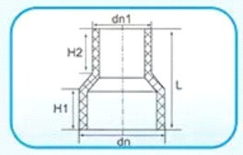
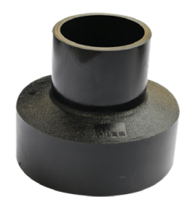

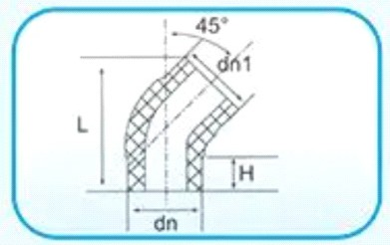
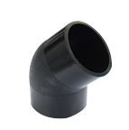
热熔对接 45°弯头

编码 | 规格 dn | L | H
 | dn63 | 165 | 63
 | dn75 | 180 | 63
 | dn90 | 185 | 63
 | dn110 | 200 | 65
 | dn125 | 215 | 65
 | dn140 | 220 | 65
 | dn160 | 250 | 75
 | dn180 | 275 | 80
 | dn200 | 295 | 80
 | dn225 | 320 | 85
 | dn250 | 350 | 85
 | dn280 | 360 | 85
 | dn315 | 390 | 85
 | dn355 | 425 | 90
 | dn400 | 470 | 100
 | dn450 | 550 | 125
 | dn500 | 600 | 125
 | dn560 | 640 | 125
 | dn630 | 690 | 125


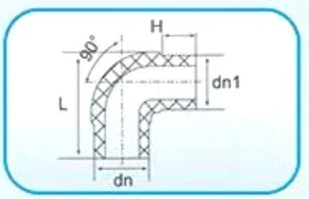
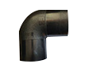
热熔对接 90°弯头

编码 | 规格 dn | L | H
 | dn63 | 67 | 132
 | dn75 | 62 | 140
 | dn90 | 62 | 155
 | dn110 | 63 | 180
 | dn125 | 70 | 200
 | dn140 | 80 | 219
 | dn160 | 72 | 234
 | dn180 | 80 | 275
 | dn200 | 100 | 310
 | dn225 | 105 | 335
 | dn250 | 105 | 288
 | dn280 | 110 | 395
 | dn315 | 112 | 435
 | dn355 | 100 | 465
 | dn400 | 110 | 515
 | dn450 | 150 | 605
 | dn500 | 150 | 655
 | dn560 | 155 | 720
 | dn630 | 155 | 790

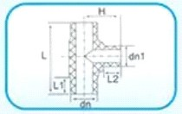
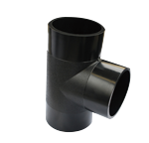
热熔对接等径三通

编码 | 规格 dn | L | H | L1 | L2
 | dn63 | 203 | 102 | 63 | 63
 | dn75 | 215 | 106 | 63 | 63
 | dn90 | 230 | 115 | 64 | 64
 | dn110 | 251 | 125 | 64 | 64
 | dn125 | 275 | 140 | 69 | 69
 | dn140 | 290 | 143 | 70 | 70
 | dn160 | 322 | 160 | 75 | 75
 | dn180 | 400 | 200 | 104 | 104
 | dn200 | 407 | 205 | 95 | 95
 | dn225 | 420 | 230 | 100 | 100
 | dn250 | 485 | 245 | 105 | 105
 | dn280 | 515 | 275 | 110 | 110
 | dn315 | 560 | 310 | 110 | 110
 | dn355 | 605 | 315 | 110 | 110
 | dn400 | 650 | 320 | 110 | 110
 | dn450 | 630 | 410 | 145 | 145
 | dn500 | 820 | 440 | 140 | 140
 | dn560 | 900 | 480 | 150 | 150
 | dn630 | 970 | 490 | 155 | 155

热熔对接异径三通

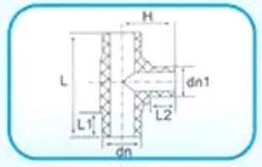  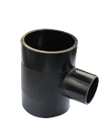   | 编码 | 规格 dn | L | H | L1 | L2
 |  | dn75X50 | 187 | 107 | 62 | 62
 |  | dn75X63 | 200 | 110 | 63 | 63
 |  | dn90X50 | 211 | 110 | 64 | 64
 |  | dn90X63 | 202 | 116 | 64 | 64
 |  | dn90X75 | 215 | 115 | 64 | 64
 |  | dn110X50 | 190 | 132 | 64 | 64
 |  | dn110X63 | 213 | 129 | 64 | 64
 |  | dn110X75 | 215 | 130 | 64 | 64
 |  | dn110X90 | 228 | 125 | 64 | 64
 |  | dn125X63 | 212 | 140 | 69 | 64
 |  | dn125X75 | 225 | 138 | 69 | 64
 |  | dn125X90 | 240 | 135 | 69 | 64
 |  | dn125X110 | 260 | 132 | 69 | 64
 |  | dn140X63 | 213 | 150 | 69 | 65
 |  | dn140X75 | 224 | 145 | 69 | 65
 |  | dn140X90 | 240 | 143 | 68 | 64
 |  | dn140X110 | 260 | 142 | 68 | 64
 |  | dn140X125 | 274 | 144 | 69 | 69
 |  | dn160X63 | 223 | 165 | 72 | 64
 |  | dn160X75 | 235 | 160 | 75 | 64
 |  | dn160X90 | 250 | 160 | 75 | 65
 |  | dn160X110 | 268 | 152 | 72 | 63
 |  | dn160X125 | 285 | 152 | 72 | 63
 |  | dn160X140 | 299 | 160 | 73 | 73
 |  | dn180X90 | 310 | 180 | 104 | 75
 |  | dn180X110 | 326 | 143 | 100 | 70
 |  | dn180X160 | 377 | 200 | 103 | 103
 |  | dn200X63 | 270 | 195 | 100 | 72
 |  | dn200X75 | 284 | 195 | 98 | 70
 |  | dn200X90 | 302 | 195 | 100 | 70
 |  | dn200X110 | 320 | 190 | 100 | 75
 |  | dn200X125 | 355 | 215 | 100 | 100
 |  | dn200X140 | 365 | 215 | 100 | 100
 |  | dn200X160 | 368 | 210 | 100 | 100
 |  | dn200X180 | 405 | 210 | 100 | 100
 |  | dn225X110 | 335 | 215 | 105 | 80
 |  | dn225X160 | 385 | 225 | 100 | 100
 |  | dn225X200 | 425 | 225 | 100 | 100
 |  | dn250X110 | 335 | 210 | 105 | 70
 |  | dn250X125 | 345 | 210 | 100 | 70
 |  | dn250X160 | 400 | 230 | 110 | 100
 |  | dn250X200 | 435 | 235 | 110 | 100
 |  | dn280X110 | 380 | 220 | 110 | 70
 |  | dn280X160 | 400 | 260 | 110 | 110

 | 编码 | 规格 dn | L | H | L1 | L2
 |  | dn280X200 | 436 | 255 | 110 | 105
 |  | dn280X250 | 490 | 255 | 110 | 105
 |  | dn315X110 | 355 | 270 | 115 | 75
 |  | dn315X160 | 407 | 300 | 115 | 115
 |  | dn315X200 | 445 | 280 | 110 | 110
 |  | dn315X250 | 497 | 315 | 112 | 112
 |  | dn315X280 | 525 | 275 | 110 | 105
 |  | dn355X110 | 335 | 265 | 100 | 80
 |  | dn355X160 | 385 | 315 | 100 | 110
 |  | dn355X200 | 425 | 315 | 105 | 100
 |  | dn355X250 | 490 | 290 | 105 | 100
 |  | dn355X315 | 555 | 300 | 105 | 110
 |  | dn400X110 | 355 | 290 | 110 | 70
 |  | dn400X160 | 405 | 330 | 110 | 110
 |  | dn400X200 | 442 | 330 | 112 | 110
 |  | dn400X225 | 495 | 320 | 108 | 110
 |  | dn400X250 | 495 | 320 | 105 | 110
 |  | dn400X315 | 560 | 330 | 100 | 105
 |  | dn450X110 | 435 | 350 | 150 | 80
 |  | dn450X160 | 485 | 380 | 150 | 115
 |  | dn450X200 | 530 | 370 | 155 | 110
 |  | dn450X225 | 550 | 410 | 150 | 110
 |  | dn450X250 | 480 | 370 | 155 | 110
 |  | dn450X315 | 580 | 380 | 120 | 110
 |  | dn450X400 | 720 | 390 | 145 | 145
 |  | dn500X110 | 430 | 350 | 150 | 80
 |  | dn500X160 | 485 | 340 | 150 | 110
 |  | dn500X200 | 520 | 400 | 145 | 110
 |  | dn500X225 | 550 | 410 | 150 | 110
 |  | dn500X250 | 560 | 410 | 145 | 110
 |  | dn500X280 | 450 | 390 | 155 | 110
 |  | dn500X315 | 640 | 400 | 145 | 110
 |  | dn500X355 | 610 | 470 | 120 | 145
 |  | dn500X400 | 728 | 460 | 150 | 150
 |  | dn500X450 | 710 | 450 | 115 | 150
 |  | dn560X110 | 460 | 380 | 160 | 80
 |  | dn560X160 | 510 | 415 | 155 | 115
 |  | dn560X200 | 510 | 415 | 155 | 115
 |  | dn560X225 | 600 | 450 | 150 | 115
 |  | dn560X250 | 600 | 450 | 150 | 115
 |  | dn560X315 | 660 | 450 | 150 | 115
 |  | dn560X400 | 740 | 440 | 160 | 150
 |  | dn560X450 | 795 | 470 | 155 | 150
 |  | dn560X500 | 840 | 470 | 155 | 150

编码 | 规格 dn | L | H | L1 | L2
 | dn630X110 | 452 | 400 | 155 | 80
 | dn630X160 | 500 | 435 | 155 | 110
 | dn630X200 | 540 | 435 | 160 | 110
 | dn630X225 | 585 | 440 | 160 | 110
 | dn630X250 | 590 | 460 | 160 | 120
 | dn630X315 | 665 | 460 | 160 | 110
 | dn630X400 | 750 | 480 | 160 | 150
 | dn630X450 | 795 | 500 | 160 | 150
 | dn630X500 | 845 | 520 | 165 | 150


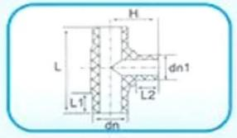
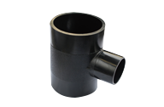

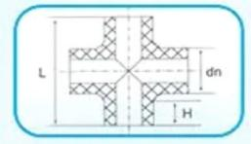
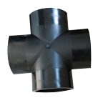
热熔对接等径四通

编码 | 规格 dn | L | H
 | dn110 | 270 | 74
 | dn160 | 330 | 80
 | dn200 | 430 | 105
 | dn225 | 455 | 105
 | dn250 | 487 | 110
 | dn400 | 645 | 150


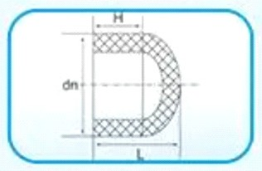
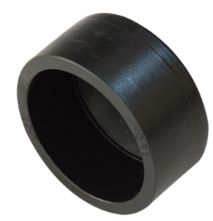
热熔对接堵帽

编码 | 规格 dn | L | H
 | dn63 | 60 | 40
 | dn75 | 60 | 45
 | dn90 | 65 | 45
 | dn110 | 85 | 70
 | dn125 | 90 | 75
 | dn160 | 105 | 85
 | dn200 | 110 | 90
 | dn225 | 100 | 78
 | dn250 | 110 | 90
 | dn315 | 125 | 105
 | dn355 | 130 | 90
 | dn400 | 110 | 90
 | dn450 | 130 | 110
 | dn500 | 120 | 105
 | dn560 | 125 | 105
 | dn630 | 130 | 95
 | dn1200

热熔对接法兰

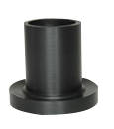  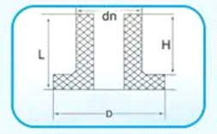   | 编码 | 规格 dn | L | H | D
 |  | dn50 | 90 | 75 | 80
 |  | dn63 | 90 | 73 | 96
 |  | dn75 | 92 | 74 | 113
 |  | dn90 | 95 | 76 | 122
 |  | dn110 | 95 | 74 | 140
 |  | dn125 | 105 | 85 | 160
 |  | dn140 | 107 | 85 | 175
 |  | dn160 | 115 | 90 | 204
 |  | dn180 | 117 | 90 | 225
 |  | dn200 | 120 | 90 | 265
 |  | dn225 | 130 | 105 | 276
 |  | dn250 长 | 200 | 170 | 320
 |  | dn250 短 | 125 | 95 | 320
 |  | dn280 长 | 203 | 170 | 322
 |  | dn280 短 | 145 | 105 | 322
 |  | dn315 长 | 210 | 170 | 370
 |  | dn315 短 | 145 | 105 | 370
 |  | dn355 长 | 202 | 172 | 430
 |  | dn355 短 | 135 | 105 | 430
 |  | dn400 长 | 204 | 172 | 485
 |  | dn400 短 | 137 | 105 | 485
 |  | dn450 长 | 240 | 195 | 530
 |  | dn450 短 | 165 | 120 | 530
 |  | dn500 长 | 260 | 215 | 590
 |  | dn500 短 | 165 | 120 | 590
 |  | dn560 长宽 | 263 | 203 | 625
 |  | dn560 短宽 | 180 | 120 | 625
 |  | dn560 长窄 | 263 | 203 | 595
 |  | dn560 短窄 | 180 | 120 | 595
 |  | dn630 长 | 280 | 220 | 690
 |  | dn630 短 | 230 | 170 | 690
 |  | dn710 长 | 326 | 250 | 800
 |  | dn710 短 | 221 | 145 | 800
 |  | dn800 长 | 310 | 250 | 900
 |  | dn800 短 | 230 | 170 | 900
 |  | dn900 长 | 328 | 258 | 990
 |  | dn900 短 | 240 | 170 | 990
 |  | dn1000 长 | 313 | 258 | 1100
 |  | dn1000 短 | 225 | 170 | 1100
 |  | dn1200 长 | 305 | 228 | 1300
 |  | dn1200 短 | 247 | 170 | 1300

对接防腐喷塑法兰盘

 | 编码 | 规格 dn | D1 | D | d | n
 |  | dn63 | 122 | 67 | 18 | 4
 |  | dn75 | 142 | 79 | 18 | 4
 |  | dn90 | 157 | 95 | 18 | 4
 |  | dn110 | 177 | 116 | 18 | 8
 |  | dn125 | 208 | 133 | 18 | 8
 |  | dn140 | 238 | 146 | 18 | 8
 |  | dn160 | 238 | 168 | 23 | 8
 |  | dn180 | 238 | 185 | 23 | 8
 |  | dn200 | 293 | 210 | 23 | 8
 |  | dn225 | 293 | 230 | 23 | 8
 |  | dn250 | 350 | 260 | 23 | 12
 |  | dn280 | 350 | 290 | 23 | 12
 |  | dn315 | 400 | 328 | 23 | 12
 |  | dn355 | 460 | 365 | 23 | 16
 |  | dn400 | 515 | 415 | 25 | 16
 |  | dn450 | 565 | 465 | 25 | 20
 |  | dn500 | 620 | 515 | 25 | 20
 |  | dn500 | 小外径，可与 DN500 阀门连接
 |  | dn560 | 725 | 570 | 30 | 20
 |  | dn560 | 大外径，可与 DN600 阀门连接
 |  | dn630 | 725 | 645 | 30 | 20
 |  | dn710 | 840 | 725 | 30 | 24
 |  | dn800 | 950 | 825 | 35 | 24
 |  | dn900 | 1050 | 925 | 35 | 28
 |  | dn1000 | 1160 | 1025 | 35 | 28
 |  | dn1200 | 1380 | 1225 | 35 | 32

焊制 22.5°弯头（30°）

编码 | 规格 dn | L1
 | dn90 | 160
 | dn110 | 160
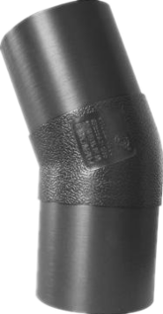  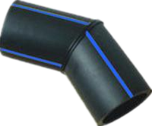 | dn125 | 160
 | dn140 | 160
 | dn160 | 160
 | dn180 | 170
 | dn200 | 220
 | dn225 | 220
 | dn250 | 220
 | dn280 | 230
 | dn315 | 250
 | dn355 | 300
 | dn400 | 350
 | dn450 | 400
 | dn500 | 450
 | dn560 | 460
 | dn630 | 500
 | dn710 | 650
 | dn800 | 650
 | dn900 | 650
 | dn1000 | 800
 | dn1200 | 800
焊制 45°弯头

编码 | 规格 dn | L1
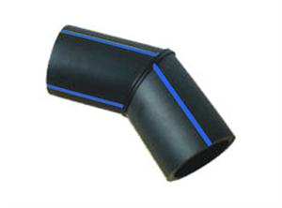 | dn140 | 160
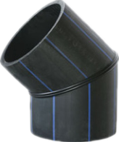 | dn180 | 170
 | dn225 | 220
 | dn280 | 230
 | dn315 | 250
 | dn355 | 300
 | dn400 | 350
 | dn450 | 400
 | dn500 | 450
 | dn560 | 460
 | dn630 | 500
 | dn710 | 650
 | dn800 | 650
 | dn900 | 650
 | dn1000 | 800
 | dn1200 | 800


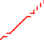
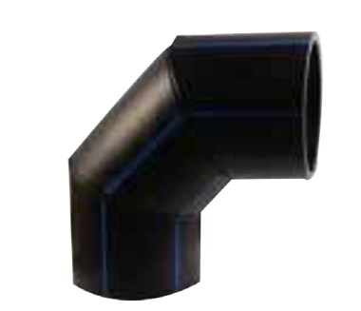
焊制 90°弯头

编码 | 规格 dn | L1 | L2 | H
 | dn140 | 200 | 150 | 375
 | dn180 | 200 | 160 | 400
 | dn200 | 230 | 160 | 445
 | dn225 | 220 | 180 | 460
 | dn250 | 240 | 180 | 495
 | dn280 | 250 | 180 | 520
 | dn315 | 300 | 220 | 615
 | dn355 | 350 | 340 | 770
 | dn400 | 370 | 360 | 830
 | dn450 | 400 | 390 | 905
 | dn500 | 430 | 420 | 980
 | dn560 | 450 | 440 | 1045
 | dn630 | 480 | 480 | 1140
 | dn710 | 590 | 540 | 1330
 | dn800 | 680 | 590 | 1500
 | dn900 | 700 | 600 | 1580
 | dn1000 | 855 | 740 | 1885
 | dn1200 | 1000 | 840 | 2200
焊制四通

编码 | 规格 dn | L | H
 | dn110 | 330 | 165
 | dn125 | 346 | 173
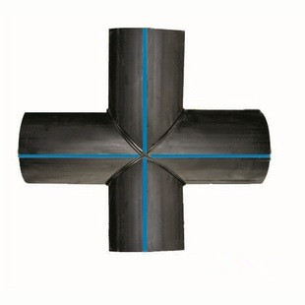 | dn140 | 360 | 180
 | dn160 | 460 | 230
 | dn180 | 480 | 240
 | dn200 | 500 | 250
 | dn225 | 525 | 262
 | dn250 | 550 | 275
 | dn280 | 580 | 290
 | dn315 | 616 | 308
 | dn355 | 756 | 378
 | dn400 | 1000 | 500
 | dn450 | 1050 | 525
 | dn500 | 1300 | 650
 | dn560 | 1060 | 530
 | dn630 | 1230 | 615
 | dn710 | 1510 | 755
 | dn800 | 1600 | 800
 | dn900 | 1900 | 950
 | dn1000 | 2000 | 1000
 | dn1200 | 2400 | 1200

焊制等径三通

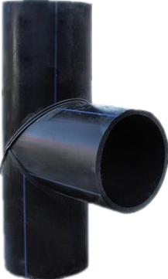  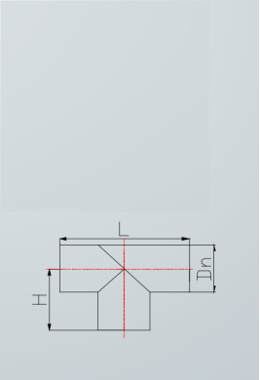 | 编码 | 规格 dn | L | H
 |  | dn140 | 440 | 220
 |  | dn180 | 480 | 240
 |  | dn200 | 600 | 300
 |  | dn225 | 620 | 310
 |  | dn250 | 640 | 320
 |  | dn280 | 680 | 340
 |  | dn315 | 700 | 350
 |  | dn355 | 940 | 470
 |  | dn400 | 1100 | 550
 |  | dn450 | 1140 | 570
 |  | dn500 | 1300 | 650
 |  | dn560 | 1360 | 680
 |  | dn630 | 1420 | 710
 |  | dn710 | 1300 | 720
 |  | dn800 | 1360 | 800
 |  | dn900 | 1420 | 900
 |  | dn1000 | 1600 | 1000
 |  | dn1200 | 2000 | 1200

焊制异径三通

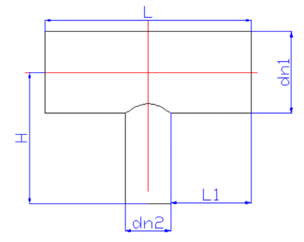   | 编码 | 规格  dn1Xdn2 | L | L1 | H | 备注
 |  | dn450X110 | 500 | 170 | 360 | 管材焊接马鞍头
 |  | dn450X160 | 552 | 170 | 375 | 管材焊接马鞍头
 |  | dn450X200 | 596 | 170 | 400 | 管材焊接马鞍头
 |  | dn450X250 | 1140 | 345 | 920 | T450+S450*315+S315*250
 |  | dn450X315 | 1140 | 345 | 755 | T450+S450*315
 |  | dn450X400 | 1140 | 345 | 755 | T450+S450*400
 |  | dn500X110 | 500 | 170 | 385 | 管材焊接马鞍头
 |  | dn500X160 | 552 | 170 | 395 | 管材焊接马鞍头
 |  | dn500X200 | 596 | 170 | 420 | 管材焊接马鞍头
 |  | dn500X250 | 1300 | 400 | 865 | T500+S500*250
 |  | dn500X315 | 1300 | 400 | 865 | T500+S500*315
 |  | dn500X355 | 1300 | 400 | 865 | T500+S500*355
 |  | dn500X400 | 1300 | 400 | 860 | T500+S500*400
 |  | dn500X450 | 1300 | 400 | 840 | T500+S500*450
 |  | dn560X110 | 500 | 170 | 390 | 管材焊接马鞍头
 |  | dn560X160 | 552 | 170 | 420 | 管材焊接马鞍头
 |  | dn560X200 | 596 | 170 | 440 | 管材焊接马鞍头
 |  | dn560X250 | 634 | 170 | 460 | 管材焊接马鞍头
 |  | dn560X315 | 1360 | 400 | 1095 | T560+S560*400+S400*315
 |  | dn560X355 | 1360 | 400 | 1100 | T560+S560*400+S400*355
 |  | dn560X400 | 1360 | 400 | 905 | T560+S560*400
 |  | dn560X450 | 1360 | 400 | 905 | T560+S560*450
 |  | dn560X500 | 1360 | 400 | 905 | T560+S560*500
 |  | dn630X110 | 500 | 170 | 425 | 管材焊接马鞍头
 |  | dn630X160 | 552 | 170 | 455 | 管材焊接马鞍头
 |  | dn630X200 | 596 | 170 | 475 | 管材焊接马鞍头
 |  | dn630X250 | 634 | 170 | 495 | 管材焊接马鞍头
 |  | dn630X315 | 1420 | 395 | 960 | T630+S630*315
 |  | dn630X400 | 1420 | 395 | 940 | T630+S630*400
 |  | dn630X450 | 1420 | 395 | 935 | T630+S630*450
 |  | dn630X500 | 1420 | 395 | 920 | T630+S630*500
 |  | dn630X560 | 1420 | 395 | 910 | T630+S630*560
 |  | dn710X110 | 560 | 200 | 425 | 管材焊接马鞍头
 |  | dn710X160 | 612 | 200 | 455 | 管材焊接马鞍头
 |  | dn710X200 | 656 | 200 | 475 | 管材焊接马鞍头
 |  | dn710X250 | 694 | 200 | 495 | 管材焊接马鞍头
 |  | dn710X315 | 761 | 200 | 515 | 管材焊接马鞍头
 |  | dn710X400 | 1300 | 295 | 1080 | T710+S710*400
 |  | dn710X450 | 1300 | 295 | 1250 | T710+S710*500+S500*450
 |  | dn710X500 | 1300 | 295 | 1060 | T710+S710*500
 |  | dn710X560 | 1300 | 295 | 1190 | T710+S710*630+S630*560
 |  | dn710X630 | 1300 | 295 | 990 | T710+S710*630
 |  | dn800X110 | 560 | 200 | 510 | 管材焊接马鞍头
 |  | dn800X160 | 612 | 200 | 540 | 管材焊接马鞍头

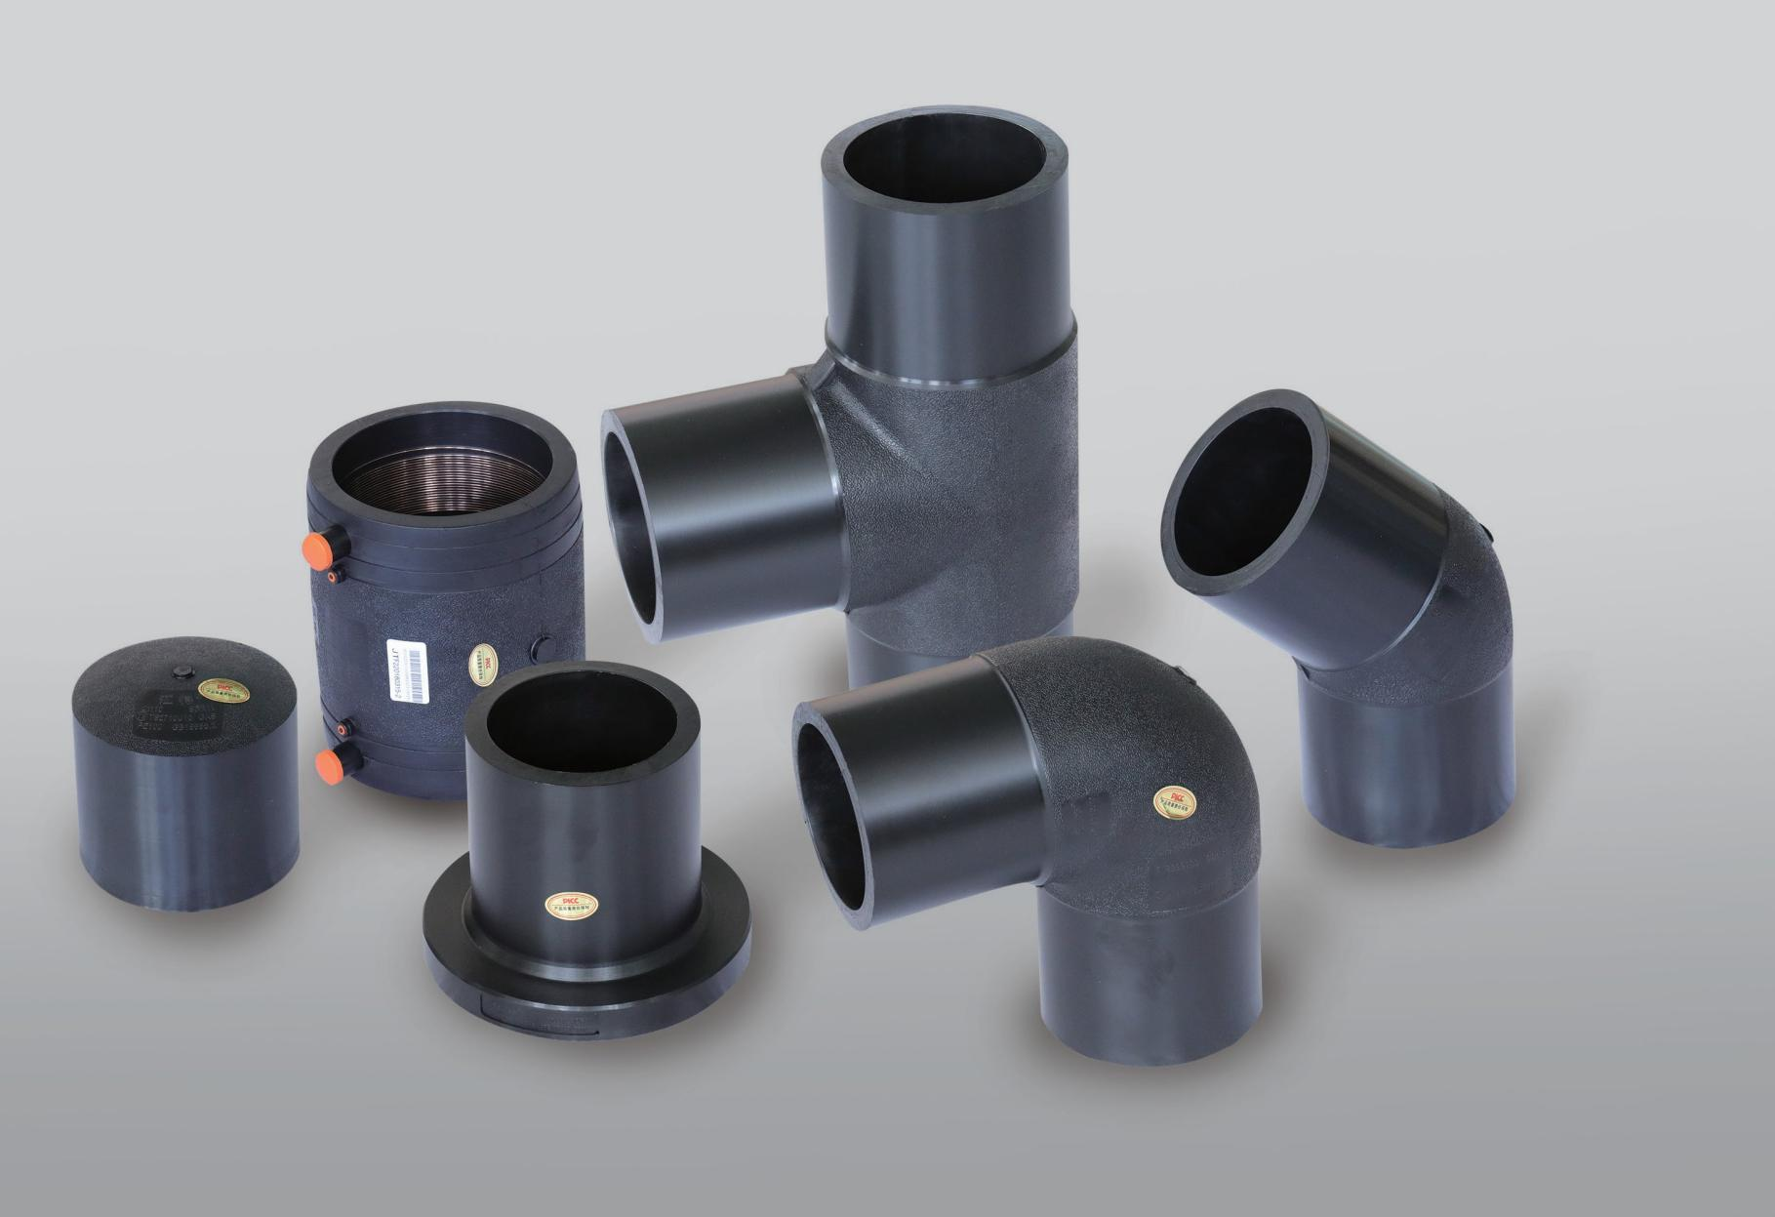
PLUS 管件（豪华版）

●纯 PE100 级混配料一次性注塑而成
●每个管件均数控加工、确保尺寸精准

异径直通
规格（mm） | L | B | A
63*50 | 158 | 68 | 60
75*63 | 153 | 79 | 68
90*32 | 162 | 84 | 49
90*40 | 163 | 84 | 54
90*50 | 164 | 84 | 60
90*63 | 166 | 84 | 68
90*75 | 167 | 84 | 75
110*32 | 175 | 87 | 49
110*40 | 176 | 87 | 54
110*50 | 177 | 87 | 60
110*63 | 179 | 87 | 68
110*75 | 180 | 87 | 75
110*90 | 181 | 87 | 84
160*63 | 220 | 103 | 68
160*75 | 221 | 103 | 75
160*90 | 222 | 103 | 84
160*110 | 215 | 103 | 87
200*63 | 254 | 117 | 68
200*75 | 255 | 117 | 75
200*90 | 256 | 117 | 84
200*110 | 249 | 117 | 87
200*160 | 240 | 117 | 103
250*90 | 298 | 134 | 84
250*110 | 292 | 134 | 87
250*160 | 284 | 134 | 104
250*200 | 286 | 134 | 117
315*110 | 345 | 155 | 87
315*160 | 337 | 155 | 104
315*200 | 330 | 155 | 117
315*250 | 324 | 155 | 134

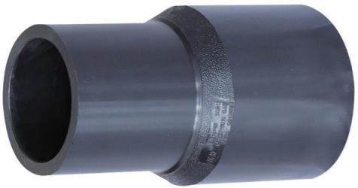

异径直通
（SDR11）

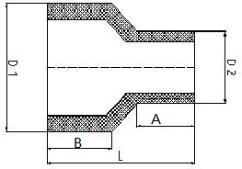

异径三通
规格（mm） | L | A | B | H
63*50 | 208 | 68 | 60 | 102
75*63 | 235 | 79 | 68 | 118
90*32 | 218 | 84 | 48 | 103.8
90*50 | 243 | 84 | 60 | 116
90*63 | 257 | 84 | 68 | 126.3
90*75 | 270 | 84 | 75 | 133
110*32 | 224 | 87 | 48 | 114
110*40 | 249 | 87 | 54 | 120
110*50 | 249 | 87 | 60 | 126
110*63 | 262 | 87 | 68 | 136
110*75 | 276 | 87 | 75 | 142
110*90 | 295 | 87 | 84 | 154
160*63 | 299 | 103 | 68 | 162
160*75 | 330 | 103 | 75 | 168
160*90 | 330 | 103 | 84 | 180
160*110 | 352 | 103 | 87 | 184
200*63 | 322 | 117 | 68 | 182
200*75 | 355 | 117 | 75 | 188
200*90 | 355 | 117 | 84 | 200
200*110 | 377 | 117 | 87 | 204
200*160 | 433 | 117 | 103 | 223
250*90 | 395 | 135 | 86 | 230
250*110 | 415 | 135 | 90 | 235
250*160 | 470 | 135 | 105 | 245
250*200 | 512 | 135 | 120 | 265
315*90 | 430 | 150 | 89 | 260
315*110 | 455 | 150 | 90 | 270
315*160 | 510 | 150 | 103 | 275
315*200 | 550 | 150 | 120 | 290
315*250 | 608 | 150 | 132 | 327

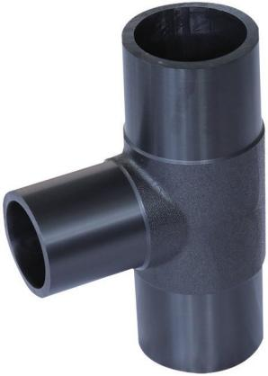

异径三通
（SDR11）

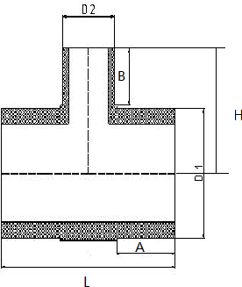

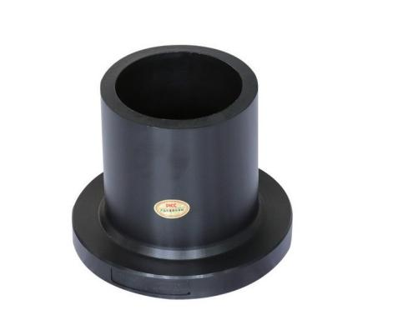
法兰头
法兰头
规格（mm） | D1 | L | A | B
63 | 102 | 86 | 68 | 13
75 | 123 | 105 | 90 | 15
90 | 138 | 114 | 99 | 15
110 | 158 | 121 | 104 | 17
160 | 212 | 144 | 122 | 22
200 | 268 | 160 | 136 | 24
250 | 320 | 193 | 161 | 32
315 | 370 | 222 | 187 | 35

（SDR11）
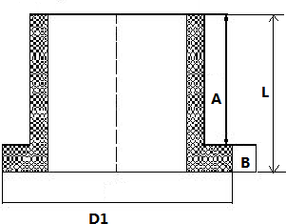

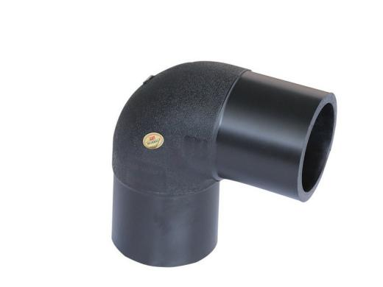

90°弯头
规格（mm） | L | A
63 | 145 | 68
75 | 159 | 75
90 | 192 | 84
110 | 217 | 89.5
160 | 284 | 103
200 | 343 | 117
250 | 390 | 134
315 | 505.5 | 155

90°弯头
（SDR11）
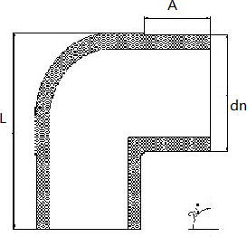

45°弯头
规格（mm） | L | A | B
63 | 175 | 68 | 89.07
75 | 200 | 76 | 105
90 | 205 | 84 | 112.73
110 | 245 | 87 | 119.9
160 | 315 | 103 | 148.39
200 | 366 | 117 | 172.84
250 | 435 | 134 | 215
315 | 527 | 155 | 255

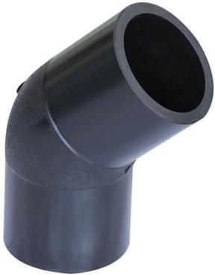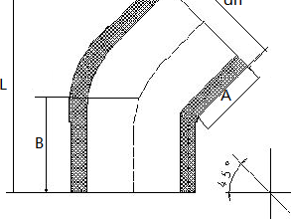
45°弯头
（SDR11）

管帽
规格（mm） | L | I
63 | 83 | 68
75 | 54 | 44
90 | 100 | 84
110 | 105 | 87
160 | 125 | 104
200 | 145 | 117
250 | 170 | 134
315 | 200 | 155
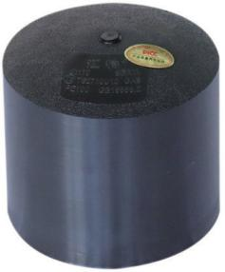
管帽
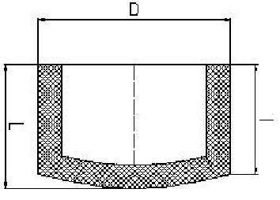
（SDR11）

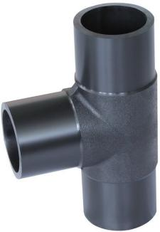
等径三通
规格（mm） | L | A | H
63 | 224.4 | 68 | 112.2
75 | 248 | 75 | 124
90 | 288.6 | 84 | 144.3
110 | 316.7 | 87 | 158.35
160 | 405 | 103 | 202.4
200 | 481 | 117 | 240.5
250 | 569 | 134 | 285
315 | 680 | 155 | 380
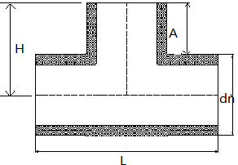
等径三通
（SDR11）



天津京通管道科技股份有限公司
总部基地：天津市宝坻区塑料制品工业区潮阳东路7号
（津蓟高速宝坻南出口右行2公里）
Tianjin Jingtong Pipeline Technology Co.,Ltd.
Headquarters address：No.7,Chaoyang East Road,Baodi Plastic Product Industrial Area,Tianjin,China 301800

Tel：+8613512272372
Wechat：13512272372
WhatsApp：+8613512272372
Website：www.cn-pipes.com
Email：cnpipes2026@163.com

